

Fort Collins Science Center

Tutorial for the Software for Assisted Habitat Modeling (SAHM) package in VisTrails.

By Marian Talbert, Colin Talbert

Report Series XXXX–XXXX

U.S. Department of the Interior

U.S. Geological Survey

U.S. Department of the Interior

Sally Jewell, Secretary

U.S. Geological Survey

Marcia K. McNutt, Director

U.S. Geological Survey, Reston, Virginia: 201x  
Revised and reprinted: 201x

For more information on the USGS—the Federal source for science about the Earth,  
its natural and living resources, natural hazards, and the environment—visit   
<http://www.usgs.gov> or call 1–888–ASK–USGS

For an overview of USGS information products, including maps, imagery, and publications,  
visit <http://www.usgs.gov/pubprod>

To order this and other USGS information products, visit <http://store.usgs.gov>

Any use of trade, product, or firm names is for descriptive purposes only and does not imply   
endorsement by the U.S. Government.

Although this report is in the public domain, permission must be secured from the individual   
copyright owners to reproduce any copyrighted material contained within this report.

**Contents**

Introduction 7

About this Tutorial 7

Getting started with VisTrails 8

Installation and Configuration of VisTrails\SAHM 8

Opening VisTrails: 8

Running your first workflow 9

Run a non SAHM VisTrails workflow: 10

Exercise: 10

Modules and packages 10

Loading a package (SAHM) and browsing its modules: 11

2) Adding, deleting, connecting, and modifying modules on the workflow canvas 11

Creating a new workflow: 13

VisTrails history view 14

Using the History view: 16

Knowing where to find help 16

Finding the difference between two history nodes 17

Getting started with species distribution modeling in SAHM\VisTrails 19

Selecting a workspace (Session Folder) 19

A typical SAHM workflow. 20

Gathering your inputs. 21

Running our first model. 24

Using the CovariateCorrelationAndSelection widget 24

Viewing the model output 29

Models fit by SAHM 31

***Generalized Linear Model (GLM)*** 32

***Multivariate Adaptive Regression Splines (MARS)*** 32

***RandomForest*** 33

***BoostedRegressionTree (BRT)*** 33

Model Output 34

Creating Curves and maps using expert knowledge (User Defined Curves) 46

Reviewing everything we’ve learned 50

Questions: 51

Presence-Only Modeling and Related Tools (Maxent) 51

Options for Selecting Background Points 52

Applying a model to a new region 55

A short digression into climate models 57

Applying a model to future climate projections 64

Applying a model to independent evaluation data 65

Parameter Exploration and Tracking model performance 67

File management in SAHM 70

Running Models with your own data 71

Gathering your Data 71

Starting a new VisTrails VT file 71

Trouble Shooting 73

References: 75

**Figures**

Figure 1. VisTrails graphical user interface (GUI). 9

Figure 2. VisTrails, modules, connections, input ports, and output ports. 13

Figure 3. Your first workflow and output will look similar to this (empty spreadsheet cells deleted here). 14

Figure 4. Components of the history view 15

Figure 5. Difference view between two workflows allows you to quickly identify what has changed. 18

Figure 6. Sections of a typical SAHM workflow 20

Figure 7. The Covariate Correlation and Selection Widget. 25

Figure 8. The Predictor Inspector Widget. 28

Figure 9. Running modules are orange 29

Figure 10. SAHM spreadsheet output . 30

Figure 11. ROC curves. 36

Figure 12. Confusion matrices. 38

Figure 13. Calibration plots. 40

Figure 14. Response curves. 42

Figure 15. Residuals map. 44

Figure 16. Creating curves from a biological understanding of the species. 49

Figure 17. Applying models to new spatial or temporal domains. 56

Figure 19. Scatterplot shows the projected change in average temperature and the percent change in precipitaton from a baseline period of 1950 to 1980 to the future period 2060 to 2080 for our study area. We have put boxes around the models we are using in this tutorial. 62

Figure 20 Problem with using a long baseline period when your data was not collected during that long period 63

Figure 21 This figure shows a workflow set up to evaluate a model fitted using one dataset on a new dataset. In the first box we perform the normal operations to fit our model. In the lower box we use the MDSBuilder to build the mds file which aggregates our input layers with the new locations and responses. Apply model is used to apply our original model to the new dataset. 66

Figure 22. Parameter exploration setup 69

Figure 24. An error encountered in a module and the corresponding error message. 74

# **Introduction**

The purpose of this tutorial is to provide a step-by-step guide to setting up and running a SAHM workflow using the VisTrails Graphical User Interface (GUI) as well as to introduce the user to the features and functionality of the Software for Assisted Habitat Modeling (SAHM) package through examples. This tutorial will use several examples to demonstrate how to input data, add and configure models to build a workflow, execute a model, modify a workflow and view the multiple types of model results. These examples will demonstrate the range of GIS tools, niche models, and options that are presently supported by the SAHM package. This document is organized to gradually introduce features and demonstrates the steps a user would generally take to build a workflow starting with the tutorial workflow and adding new modules to customize the application to fit their needs. This tutorial is intended to accompany the SAHM user guide (SAHM_UserGuide.docx which can be downloaded from: <https://my.usgs.gov/catalog/RAM/SAHM> or if you’ve installed SAHM in the default location at: C:\VisTrails_SAHM\vistrails\packages\sahm\SAHM_UsersGuide.docx). The SAHM user guide provides much more detailed information on installation, a VisTrails Primer, and documentation for each module in the SAHM package as well as information on interpreting model evaluation metrics.

# About this Tutorial

The data set we are going to be looking at consists of count data for Brewer’s sparrow (Spizella brewer) in the Wyoming Basins, USA. The data were obtained from two sources, the Breeding Bird Survey (BBS) and the Sagebrush Ecosystem Conservation and Management: Ecoregional Assessment Tools and Models for the Wyoming Basins website (<http://sagemap.wr.usgs.gov/wbea.aspx#CAdata>). The data were collected as species counts but will be aggregated to presence/absence and presence-only for demonstration purposes in this tutorial.

Throughout this document, sections to follow along are highlighted in gray boxes. Note, all file paths are assuming a default installation on a Windows system. File paths will be relative to the SAHM examples folder otherwise.

# Getting started with VisTrails

## Installation and Configuration of VisTrails\SAHM

In order to work through this tutorial you must have downloaded and installed VisTrails and SAHM as well as its dependencies Java and Maxent. Detailed instructions for this installation are available in the SAHM User Guide (Which can be downloaded from: <https://my.usgs.gov/catalog/RAM/SAHM>) . It might also be helpful to review the section of the user guide entitled “VisTrails Primer” which provides basic information about working in VisTrails. Additionally, comprehensive explanations of all SAHM modules and parameters can be found in the user guide as well as in the module documentation as described later.

#### Opening VisTrails:

1. Open VisTrails by clicking on the icon in your start menu or on your desktop.
2. Notice that two windows came up. The first is the main application in which you will be doing all of the exercises. The second is a read only command console that you will want to check for warnings, errors, and status messages while running workflows. The main application window is shown below with a few of its main items highlighted.

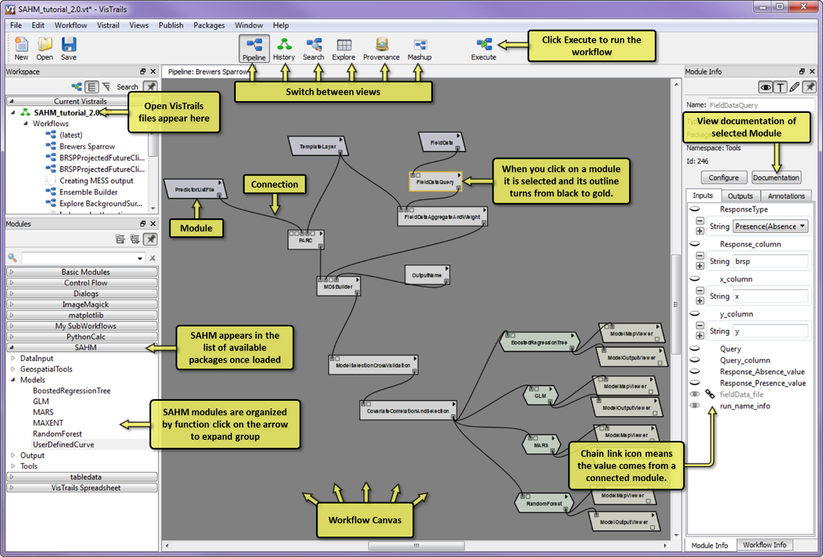

Figure 1. VisTrails graphical user interface (GUI).

Note that SAHM will not be visible until loaded in a following section, unless you’ve used it previously.

## Running your first workflow

In order to get acquainted with VisTrails we’re going to run our first workflow. VisTrails, the scientific workflow and visualization tool, is designed for a wide range of scientific fields. To demonstrate this flexibility we’ll be running one of the built in example workflows that use 3D medical imaging.

#### Run a non SAHM VisTrails workflow:

1. Open the built-in VisTrails example called ‘head.vt’ by clicking File->Open->C:\VisTrailsSAHM\examples\head.vt (if you see any messages about enabling packages click ‘ok’.
2. Make sure you are in the ‘History’ view by clicking the History icon in the top bar.
3. Click on the orange oval labeled ‘bone_camera’ or if present the blue Upgrade oval directly below.
4. Click the ‘Execute’ icon on the top bar.
5. Click on the orange icon labeled ‘volume rendering’ or if present the blue Upgrade oval directly below.
6. Click the ‘Execute’ icon again.
7. A spreadsheet should appear with two cells filled with images of a human head.
8. Try clicking and dragging in one of the cells to manipulate the 3D image.
9. When finished, close the vt file by clicking “File” then “Close”.

#### Exercise:

Take a few minutes to try out a few of the other vistrails (*.vt) files in the examples folder. Note that not all examples will work.

If you would like additional VisTrails tutorials and explanation please see: <http://www.vistrails.org/usersguide/v2.2/html/example.html#learning-vistrails-by-example>

Much of this material we will be covering in the context of species distribution modeling using the SAHM VisTrails package.

## Modules and packages

In VisTrails all workflows are made up of modules that represent an individual data input or processing step. Modules are organized into packages that contain collections of modules related to a single topic. For example SAHM contains modules used for species distribution modeling, Basic Modules contains general purpose modules, VTK contains modules for 3D visualization, etc. It is possible, and often quite useful, to combine modules from multiple packages into a single workflow but for the workflows in the rest of this tutorial we’ll only be using modules found in the SAHM package. The list of available module packages is found on the left of the main VisTrails application. If you haven’t previously loaded or run a SAHM workflow you’ll notice that SAHM is not in this list.

#### Loading a package (SAHM) and browsing its modules (optional):

1. To load the SAHM package click Edit->Preferences
2. On the form that pops up click the Module Packages tab.
3. The list of available packages are found on the left of this form divided into disabled and enabled groups.
4. If SAHM is currently disabled you can enable it by selecting SAHM in the Disabled packages list and clicking the Enable button.
5. Optional: While you’re in this tab disable the vtk package. We used it in the head example above but having it enabled makes opening VisTrails slower and we won’t be using it for the remainder of this tutorial.
6. Click close.
7. SAHM now appears in the Modules pane at the lower left.
8. Expand the SAHM package by clicking on it in this list and likewise examine the contents of GeospatialTools group beneath it.
9. We’ll be using some of the modules in this group in the following two exercises.

## 2) Adding, deleting, connecting, and modifying modules on the workflow canvas

In VisTrails, workflows are created or modified on the workflow canvas in the Pipeline view. A workflow represents a set of inputs and a series of processing steps used to create an output. Each of these individual inputs or processing steps, or modules, is represented as gray box in VisTrails. Each module has specific input parameters that are unique to its data type or processing purpose. For example a raster layer module might have an input parameter that specifies which file it points to, and another parameter that specifies the color ramp used to display it on a map. These parameters, also known as ‘input ports’ in VisTrails, can appear as small boxes at the top left of a module. In addition to the main input ports that are shown as small boxes on the module, a module can have other, often optional, parameters that can be seen in the Module Info tab on the right of the application. Each result produced is passed out of the module through an ‘output port’ which is displayed as a small box on the lower right of the module.

Setting the parameter values for a module can be accomplished two ways. The first is to set or edit the value shown in the Module Info tab when the module is selected in the workflow canvas. You might first need to click the parameter label to show the current parameter value or default. The second method for setting a parameter value it to connect the output port from another module to the input port for that module. For example the output port of a module that produces a file can be connected to the input port of a module that manipulates a file. 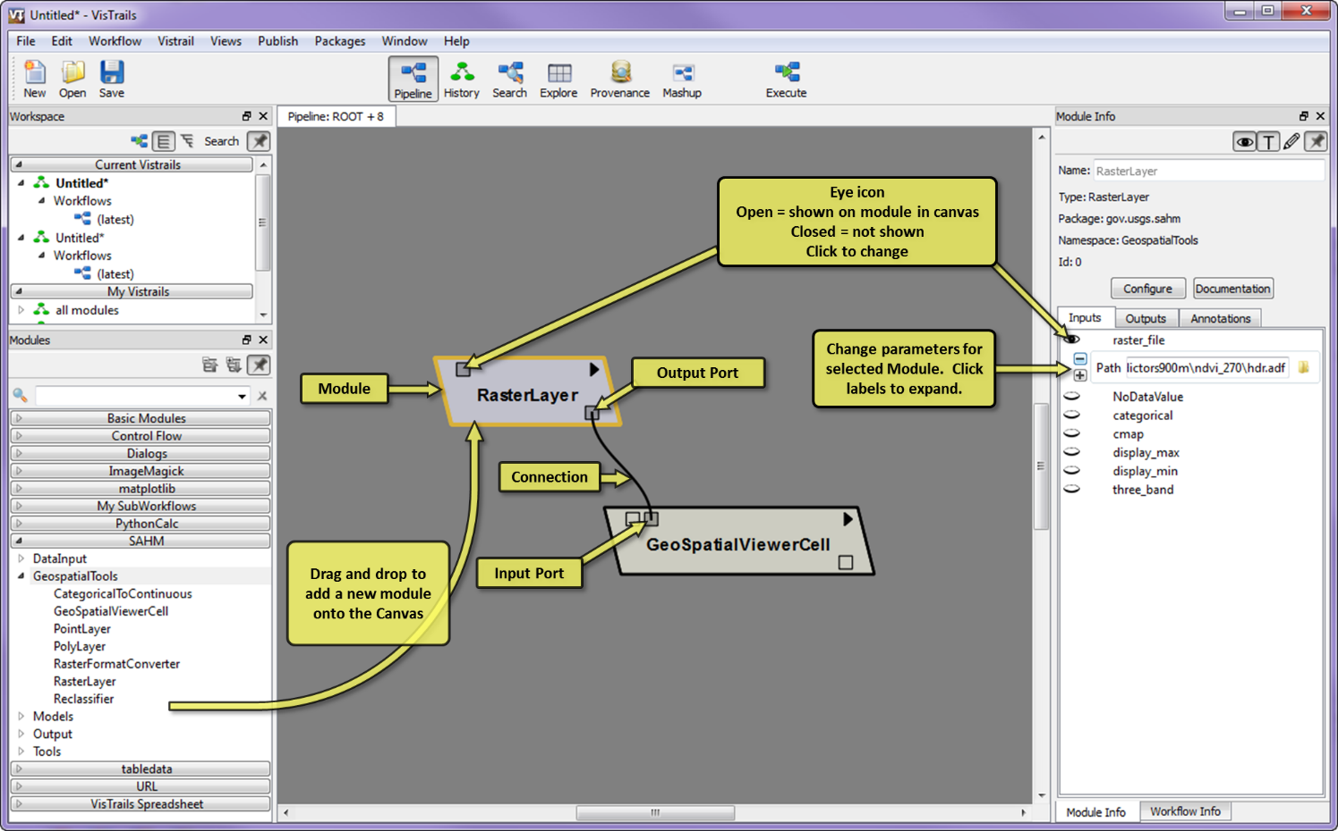

Figure 2. VisTrails, modules, connections, input ports, and output ports.

#### Creating a new workflow:

1. Click the ‘New’ icon just below the File drop down menu to get a blank canvas (and .vt file).
2. Under Modules to the left of the canvas Expand the SAHM bar by clicking on the triangle; this should give you several subheadings.
3. Click on the triangle next to the subheading GeospatialTools you should now see a list of geospatial modules.
4. Click and drag a RasterLayer module from the list of SAHM modules onto the gray workflow canvas. Notice that the list of Inputs on the right panel were updated to show inputs specific to a raster layer.
5. Click the raster_file parameter in this list and the folder icon below this. Now navigate to a raster layer ("C:\VisTrails_SAHM\examples\SAHM_example\Covariates\WBEA\ndvi_270\hdr.adf").
6. Next drag a GeoSpatialViewerCell into the central canvas.
7. In order to connect these modules we need to click in the output port of the RasterLayer and drag the connection to the GeoSpatialViewerCell input port called ‘raster_layers’. You can check what an input port is called by hovering over it. Note that there are two possible input ports on the GeoSpatialViewerCell that it can connect to. Make sure it connects to the one called ‘raster_layers’ and not ‘vector_layers’.
8. Click the ‘Execute’ icon. A map should appear in a new sheet on your spreadsheet.

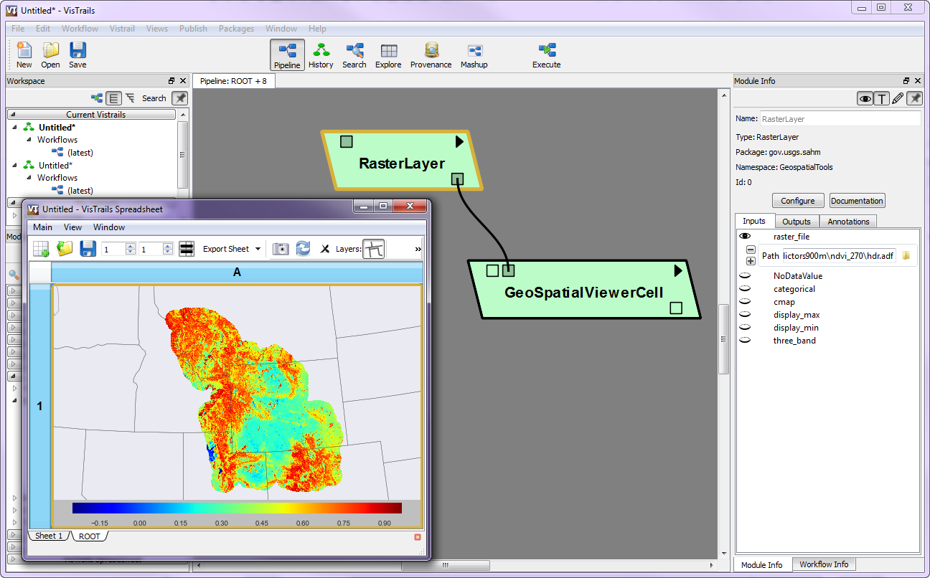

Figure 3. Your first workflow and output will look similar to this (empty spreadsheet cells deleted here).

## VisTrails history view

In the previous section we were editing a workflow in the pipeline view. While we were doing this VisTrails was recording each change we made to the workflow in a detailed history. To see this click on the History icon and click the small plus square to expand the history fully. You should see something like this:

Each oval in this chain represents a change made to the initial workflow which was a blank canvas. First we added a module (RasterLayer) then we added a parameter by pointing to a raster file. To see what that workflow looked like you can select one of these history ovals and click the Pipeline icon. Since this level of history detail quickly becomes overwhelming it is important to make a tag or bookmark by annotiating significant steps in the workflow development.

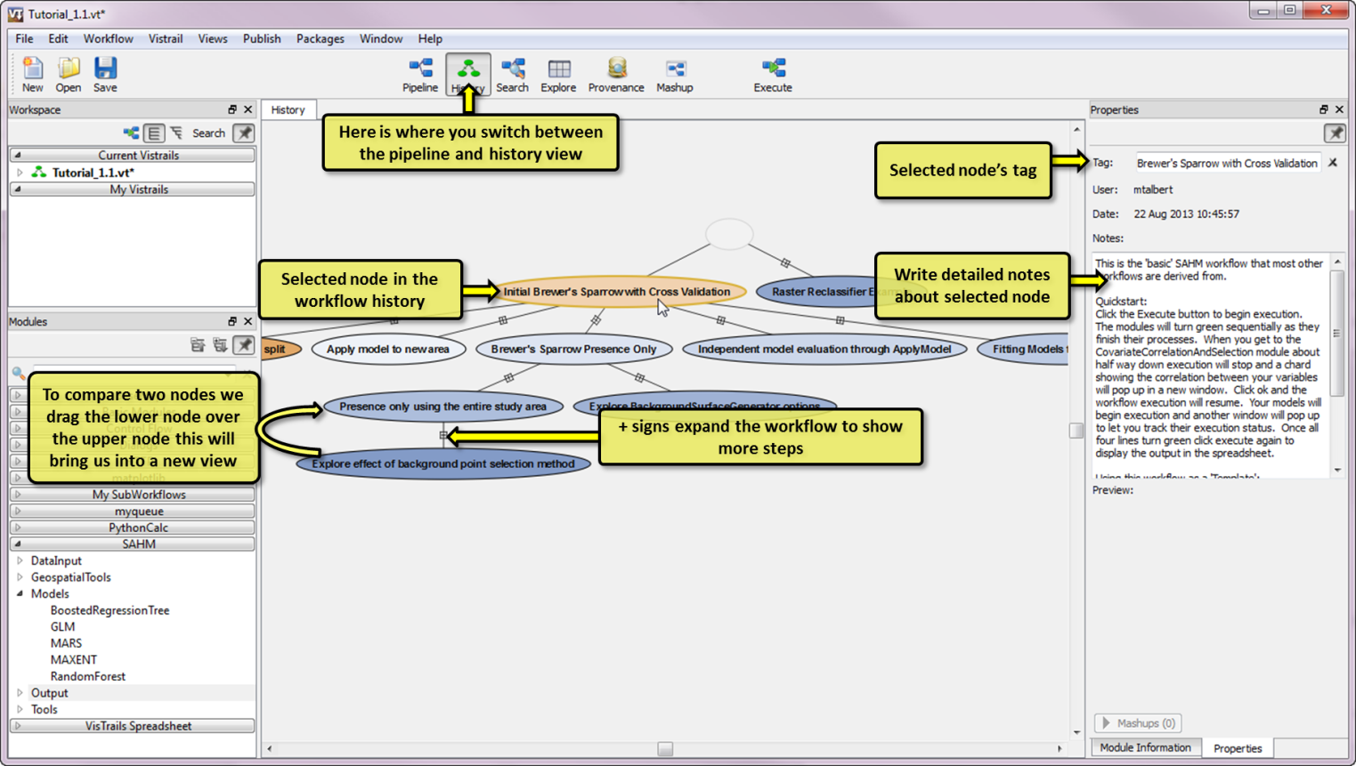

Figure 4. Components of the history view

#### Using the History view:

1. Click on the History icon if you haven’t already, and click the – icon below the empty oval to minimize the history if it’s not minimized already.
2. Let’s pretend that the map output we just created was going to be a figure in an upcoming paper. In order to recreate this output we’ll need to tag this node in the workflow. To do this make sure the last node in the history chain (‘Added connection’) is selected and type ‘Figure 1’ in the Tag textbox the right.
3. This tag now becomes a bookmark we can easily return to. Additionally you can add notes about what was done in the Notes box. Type ‘My first map in VisTrails’ there now.
4. Now let’s say an editor came back and said that the color map you should have used for NDVI is Red to Green, and you should have lumped all values over 0.5 with the top color. No problem you say. Switch back to the Pipeline view, click on the RasterLayer Module so it is highlighted in gold and to the right of the canvas under the Inputs tab change the ‘display_max’ parameter to 0.5 and select ‘RdYlGn’ for the ‘cmap’ parameter.
5. Click execute and notice how these changed parameters changed your output.
6. Go back to the history view and tag this workflow as ‘Fig 1 edits’ by double clicking in the appropriate oval. You can record more detailed notes to the right of the canvas in the notes area. These are specific to the highlighted node in the history.
7. At this point you can easily go back and recreate either of these outputs by selecting the clearly labeled node in your history.
8. In practice you should use this method to tag/bookmark your progress periodically. Failure to do so limits the reproducibility of your work.

# Knowing where to find help

It is worth pointing out at the outset where the user can find help when trouble arises. When any module is highlighted within a VisTrails workflow the user can click the Documentation button to the left of the workflow canvas in the pipeline view. We have provided detailed information on the likely input and output ports for each module as well as the formats required for each parameter. If one desires information on a specific input or output right click on the Input\Output name and click view documentation. The SAHM user guide also provides detailed documentation on each module as well as information on interpreting output. At the end of this tutorial we have included a section on troubleshooting when errors occur. We have also put together a SAHM Google group (https://groups.google.com/forum/#!forum/vistrails-sahm) which is a forum where SAHM users can post questions and generate discussions about species distribution modeling and where SAHM developers can provide information on the latest updates to the software.

Finding help:

1. In the workflow we just created click the small triangle in the upper right corner of a module in the canvas such as RasterLayer and select ‘View documentation’ in the dropdown. This is the complete documentation for the entire module.
2. Select the GeoSpatialViewerCell on the workflow canvas by clicking on it. Now right click on the input parameter labeled display_states and select ‘View documentation’. This technique can be used to get just the documentation for a single parameter.
3. Expand the DataInput section of the SAHM modules list in the left panel. Right click on ‘Template Layer’. This technique is handy when exploring the available modules.

Exercise:

Determine what default ThresholdOptimizationMethod is used by the BoostedRegressionTree model.

## Finding the difference between two history nodes

For the remainder of this tutorial we’ll be working off of the SAHM tutorial vistrail (.vt) file which can be found in the SAHM example folder.

If we want to know exactly what was changed between two workflows (history nodes) we can click on a node and drag it on top of another node, which brings us to a difference view that looks like a pipeline but actually highlights the differences in the modules, connections and parameters between the two selected history nodes (see Figure 5).

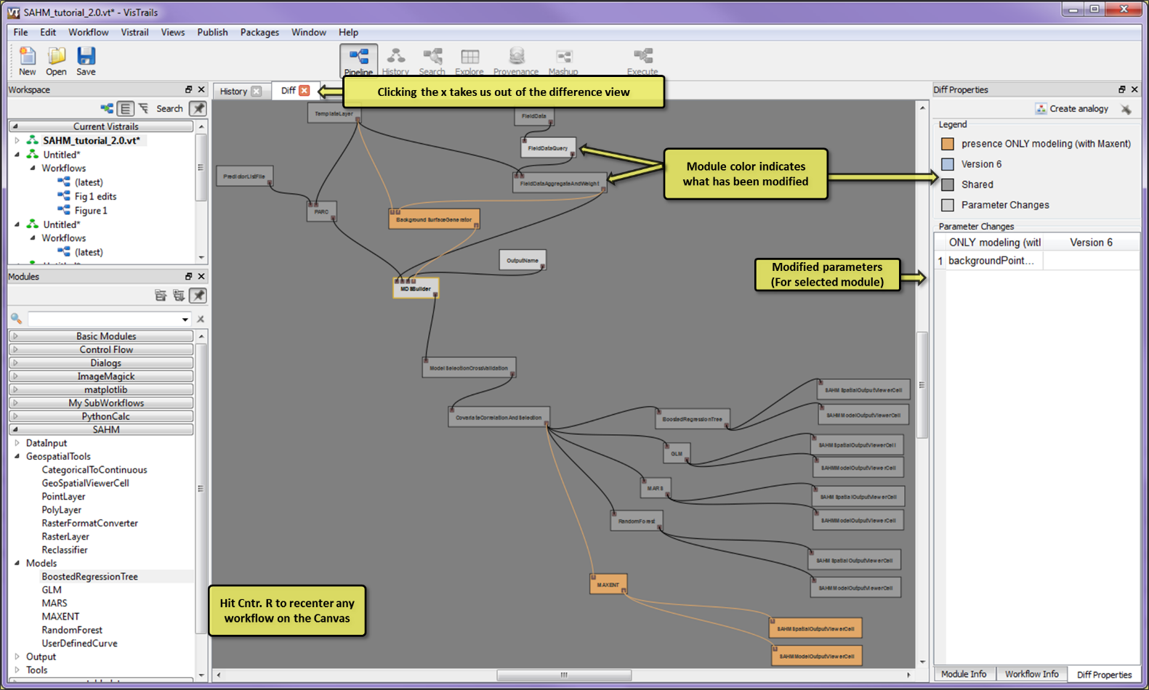

Figure 5. Difference view between two workflows allows you to quickly identify what has changed.

Try Comparing Nodes in the History:

1. Open the SAHM tutorial .vt file by selecting File->Open and browsing to C:\VisTrails_SAHM\examples\SAHM_example\SAHM_tutorial_2.0.vt.
2. Switch to the history view.
3. Try comparing the presence ONLY modeling (with Maxent) node in the history to the Brewers Sparrow node by dragging the former over the latter.
4. Which modules were added?
5. What parameters were changed within modules?

# Getting started with species distribution modeling in SAHM\VisTrails

# Selecting a workspace (Session Folder)

In SAHM the workspace is the folder where all your output from the very initial preprocessing through the final model output are stored. All evaluation metrics and graphics are also saved in your session folder so that you can find and use these as needed outside of VisTrails, for example opening map output in a GIS, copying diagnostic charts into a report, etc. You do not need to move your original input data into this folder. When using VisTrails/SAHM it is generally useful to organize each modeling effort or project with its own session folder.

Changing the session folder:

1. The default session folder location is not very descriptive of the modeling we’re about to do. We need to change this so that we will know where to find these specific outputs in the future.
2. To do this click on the ‘Packages’ menu item at the top of the application, select SAHM from this list and click ‘Change session folder’. Browse to your C:\temp folder and create a subfolder called ‘BrewersSparrow_tutorial’
3. Click select folder. You’ll notice that a message was added to the console output noting that the output directory changed.

Exercise:

In Windows Explorer navigate to the folder we just created. Notice that it is empty except for a file called sessionLog.txt. This file contains a copy of all the console output as well as additional warning and error messages. It can be useful as an external record of what processing was done as well as an aide for debugging problems you encounter.

As we work through this tutorial you will notice additional outputs getting created in this folder.

# A typical SAHM workflow.

The typical basic SAHM workflow can be divided into five sections: inputs, pre-processing, data partitioning and exploration, model fitting, and output visualization. We’ll be going through each of these in turn in the subsequent sections of this tutorial. Also note that while each section builds off the previous, all components are not required for all workflows. The flexible nature of VisTrails allows for doing the spatial pre-processing in an external GIS program, doing the spatial preprocessing in VisTrails but using the output for a different type of modeling, or aggregating and visualizing SAHM output in another program.

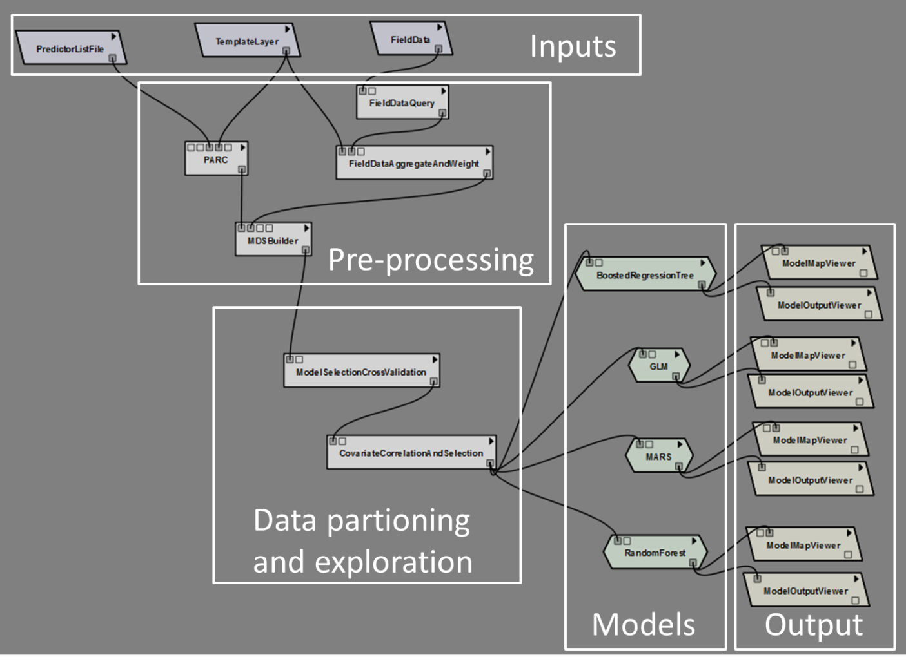

Figure 6. Sections of a typical SAHM workflow

# Gathering your inputs.

A typical SAHM workflow requires three data inputs.

1. A set of species occurrence (and possibly absence) locations. Currently only comma separated value (CSV) text files are readable. There is some flexibility in the file format; it must contain X, Y positional information and an indication if the species was found at that location.
2. A template raster file used to specify study extent, resolution and projection. This can be any common raster format including tif, img, jpg, and ESRI grids among others. It must have a defined projection. Any areas of nodata in the template will be masked out of the model.
3. A set of rasters containing environmental covariates. These raster files can also be in any number of formats. They do not need to be in the same projection, resolution or extent before beginning.

Examining the Brewer Sparrow observations:

1. Our species occurrence data is in the file: "C:\VisTrails_SAHM\examples\SAHM_example\SpeciesLocations \BBScombined.csv" Open this file in Excel or a text editor of your choice.
2. Notice that it contains x,y location data in the 7th and 8th columns. These data are in an unprojected WGS84 coordinate reference system (CRS) (EPSG code of 4326).
3. Notice that count data for 6 different species are found in the first six columns. Brewer’s sparrow data are in the brsp column. Although modeling against count data is supported in SAHM we’ll be collapsing these detections to 0 or 1 (1 or more individuals).
4. While it is possible to reformat this file in Excel to strip out extraneous columns and collapse the count column we’ll be using SAHM to do this data pre-processing in a subsequent step. Using SAHM for this has the advantage of recording exactly what processing steps were used and can facilitate running models for multiple species.
5. You can leave this file open to refer back to as we set up the rest of the workflow.

Examining the template raster:

1. The template file we’re going to be using is: "C:\VisTrails_SAHM\examples\SAHM_example\Covariates\WBEA\asage_1km" If you have a separate GIS program examine this layer there.
2. Notice that it is in an Albers equal area NAD27 projection, which is different than the WGS84 CRS our occurrences are in.
3. Also notice that it covers much of western WY at a 900 m cell size which results in 573x604 columns and rows. This is a convent size for relatively fast computation. When processing larger extents or using smaller cell sizes processing can take much longer or fail altogether. For example processing this model against 30m data for Wyoming might take hours instead of minutes. Processing it against 30m data for the western US might take days or weeks if it finished at all.
4. Finally notice that there is a collar of nodata around an area of data with a value of 1. The fact that this is 1 is irrelevant but areas of nodata are masked from subsequent steps.

Examining the raster covariates:

The initial model runs we’re going to do use 7 environmental covariates which can be found in the folder: ..\Covariates\WBEA

1. asage_1km is the proportion of all sagebrush in a 1km moving window.
2. cfrst_18km is the proportion of all sagebrush in a 18km moving window.
3. mix_18km is the proportion of all mixed shrubland in a 18km moving window.
4. ndvi_270 is average NDVI in a 0.27km moving window.
5. rddens_18km is the road density in a 18km moving window.
6. rip_540m is the proportion of riparian vegetation in a 540 m moving window.
7. Tri_18km is a topographic ruggedness index at a 18 km scale.

And 5 climate covariates which can be found in the folder ..\Covariates\Maurer_obs_2000-2005. Each of these were calculated from data available at: <http://hydro.engr.scu.edu/files/gridded_obs/monthly/ncfiles_2010> for the years 2000-2005 at a native resolution of 12 km.

1. Bio1 is the annual mean temperature
2. Bio5 is the maximum temperature of the warmest month
3. Bio6 is the minimum temperature of the coldest month
4. Bio12 is annual precipitation
5. Bio13 is precipitation of wettest quarter

Don’t worry about examining these in too much detail here, in the next section we’ll get a chance to do so from within VisTrails.

# Running our first model.

Running the node tagged “Brewers Sparrow”:

1. Open the SAHM tutorial VisTrail which can be found at: "C:\VisTrails_SAHM\examples\SAHM_example\SAHM_tutorial_2.0.vt"
2. If it didn’t take you to the History view switch to this view now.
3. Select the node labeled “Brewers Sparrow” and switch back to the Pipeline view.
4. Notice that the workflow under this node is quite similar to the typical SAHM workflow shown in figure 1. Orient yourself with the sections of the workflow in your VisTrails application as labeled in that figure.
5. Click Execute above. Don’t worry about exactly what each module is doing we’ll go into more detail subsequently. Notice as it runs that modules turn green as they finish up. The order they execute in is not specified but all upstream modules must complete before any downstream modules execute.
6. While it is running this first model check the console window for messages.
7. Check in the session folder to verify that it is producing outputs as modules finish up.

When the workflow gets to the CovariateCorrelationAndSelection module, execution will pause and an interactive window displaying the correlation between the covariates used will appear. Sometimes you must hover over the VT icon on the application bar of your computer and select this window to bring it to the front.

## Using the CovariateCorrelationAndSelection widget

If you are following along this tutorial sequentially you should have the CovariateCorrelationAndSelection widget up now. If not follow the directions in the previous section to get to this point. The widget that you are seeing should appear like Figure 7.

Data inspection is a critically important step in fitting models. Many times there are unexpected problems with data that can be identified by close inspection. Midway through our typical workflow we use the CovariateCorrelationAndSeleciton module to perform a detailed inspection of the data and to filter out highly correlated predictors, which if left in the model can lead to erratic performance for slightly different data and poor ability to predict even within the environmental space used for model calibration. We have implemented an interactive display to allow the user to iterate through the iterative process of covariate filtering. This display works by sorting on the covariates that have the highest number of correlations above some threshold (by default 0.7) with other predictors under consideration. This allows the user to view and remove those predictors with the greatest number of correlations in a sequential order, which can be extremely useful when the initial number of predictors is high. 

Figure 7. The Covariate Correlation and Selection Widget.

From this display we can easily see several useful items. The relationship between each predictor and the response are displayed in the far left column, with left most labels giving the percent deviance explained in a univariate model (with just the one predictor and the response). We can see above the top row the total number of correlations each predictor has above our selected threshold (0.7 by default) with other predictors. If any observations are missing for a given predictor, this information will be displayed across the top as well. The upper right portion displays the highest of the Pearson, Spearman, and Kendall correlation coefficients between each pair of predictors and the bottom right portion shows the scatterplot relationship between each pair of predictors. A standard rule of thumb is to remove any predictors with a correlation with another predictor above 0.7. Failure to remove highly correlated predictors can lead to unstable model fits in which minor changes to the data or model parameters can give drastically different answers and unreliable predictor estimates. Decisions about which predictor to remove should be based primarily on a biological understanding of what is important to the organism, but other factors such as patterns in missing data or the relationship between each predictor and the response can also be taken into consideration. The predictor inspector widget can help you with this. 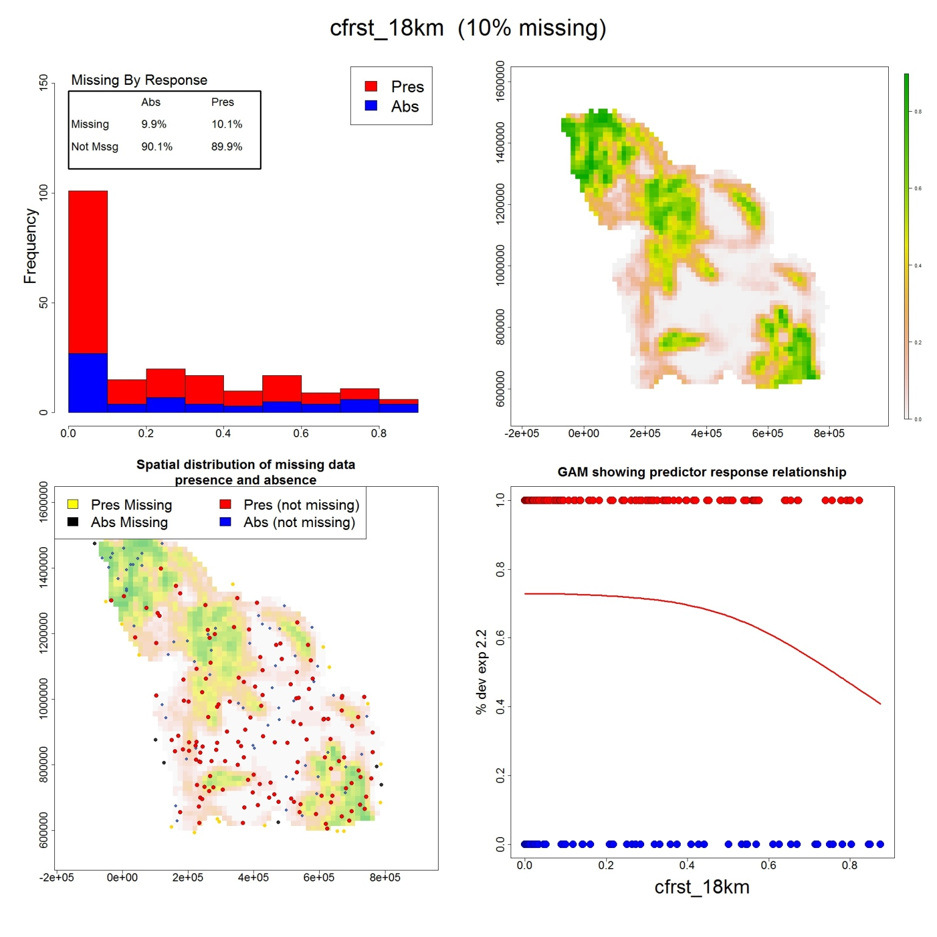

Using the Covariate Correlation Widget:

1. If you haven’t done so yet, work through the steps in ‘Running the node tagged “Brewer’s Sparrow”’ above.
2. Try checking the boxes for some of the predictors in the left hand column in the Include section in the upper left and then click the update button in the bottom left to see the correlation relationship between the remaining predictors.
3. Identify the two covariates that are most strongly correlated. Which explains the most deviance? Hint: this is shown on the left axis of the mini chart showing the relationship to the response. You can also see this for all covariates by grabbing and sliding right the divider between the list of covariates on the left and the main matrix.
4. Clicking on the labels Include and % Deviance Explained allows sorting on either of these components.
5. Notice that cfrst_18km has several high correlations with other predictors and is also missing for 10% of the observations. The patterns of no data should be understood so double click on cfrst_18km in the left hand column. After a few minutes you should see Figure 8.
6. The spatial pattern in no data is around the outside of the shape and is related to resampling in this case and you will notice that there doesn’t seem to be a relationship between no data and the response which is good (upper left box). Keeping this predictor would mean throwing out any incomplete records which would be 10% of the data. Given this and the high correlation with other predictors let’s remove this from further consideration by unchecking it after closing the predictor inspector (click the x in the top right corner).
7. Bio_12 and Bio_13 are annual precipitation and precipitation of the wettest month respectively and clearly one should be removed. The selection process should be driven by what’s known about the biology of the organism or the relationship that ecologists are hoping to elucidate but since we don’t have any biological insight into what drives Brewer’s Sparrow we will continue removing predictors based on their correlation with other predictors and those with low percent deviance explained until no more highly correlated predictors are included.
8. Click update to update the Covariate Correlation viewer and click OK to accept the current list of predictors and continue with the model fitting process.

Figure 8. The Predictor Inspector Widget.

The four models in the workflow will begin executing and their color will turn from grey to orange. This color indicates that they are currently running, and downstream modules will wait for them to complete before executing. When your models finish running the output will be sent to a spreadsheet sheet labeled ‘Brewer’s Sparrow’ and the rest of the workflow will turn green. 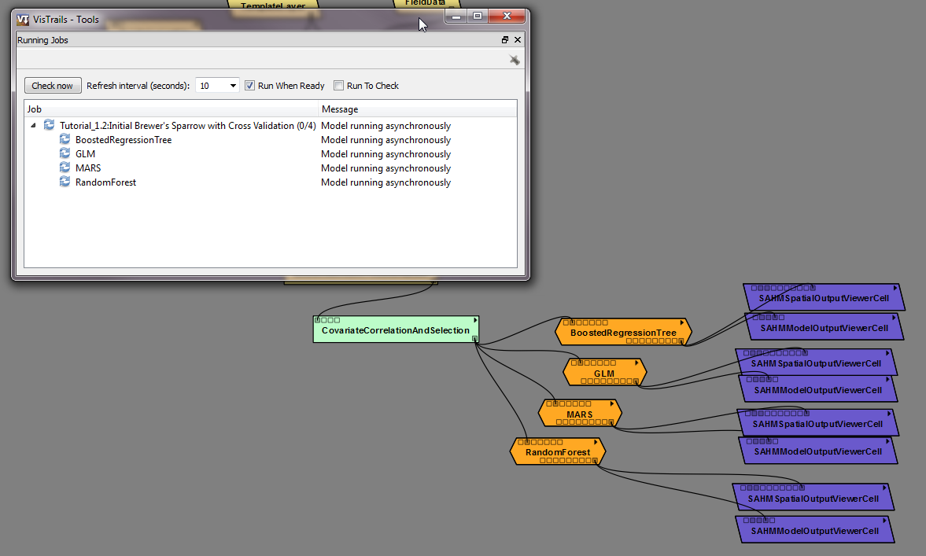

Figure 9. Running modules are orange

# Viewing the model output

We’ve already seen the VisTrails spreadsheet in some of the previous sections, but here we’ll be taking fuller advantage of it. SAHM output cells in the spreadsheet contain either a mini-Geographic Information System (GIS) of the predictive maps (ModelMapViewer) or a widget that displays various charts used to analyze model performance (ModelOutputViewer). Organizing output in this fashion using the spreadsheet allows us to quickly, and in great depth, compare the myriad of comparable output inherent to these modeling techniques produced from multiple model runs.

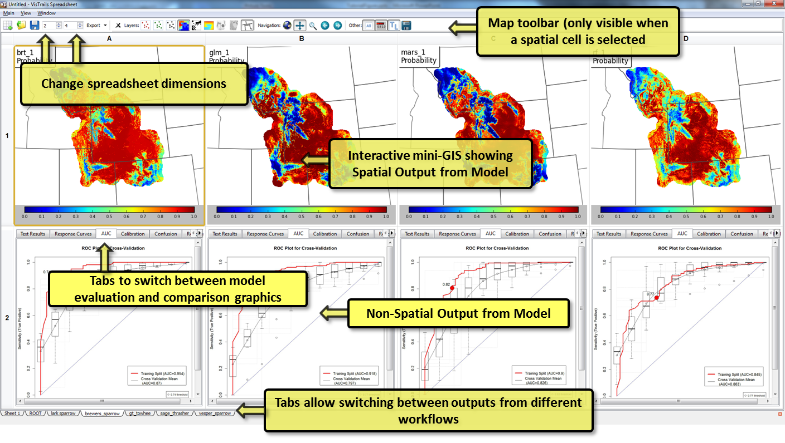

Figure 10. SAHM spreadsheet output.

In this workflow the top row in this spreadsheet contains the spatial output and the bottom row contains the model output, including charts and other quantitative model output. If you click on one of the map cells, a mini-GIS toolbar appears above the spreadsheet which allows you to interact with the maps. For example, you can turn on or off the presence/absence points, switch between probability, binary, or other map outputs, or change the cursor from zooming or panning modes. Note that when zooming or panning all maps will track together. More information about the specifics of functionality is included in the SAHM User Guide. The model output row includes tabs to switch between the different charts, textual, and other quantitative output.

Examining the model predictive maps in the Spreadsheet:

1. Your spreadsheet output should look similar to Figure seven. If not run through the previous two sections to get this up. If your model modules are still orange you’ll need to wait for them to finish up.
2. Right click in one of the map cells to display a list of options. Notice that the icons available from the popup menu are also available on the toolbar above the spreadsheet.
3. Select the options to display the presence (red) and absence (green) points from the map toolbar. How does the pattern of observations correspond to the predicted probability surface? Try zooming (magnifying glass icon) and panning (crossed arrows icon) to see more detail.
4. You can also switch to the binary or residual map using the options under Layers in the map toolbar

## Models fit by SAHM

Currently five models are available in the SAHM package. Maxent is used for modeling presence only data. Generalized Linear Model (GLM), Multivariate Adaptive Regression Splines (MARS), Boosted Regression Tree (BRT), and Random Forest (RF) are appropriate for fitting models to presence/absence data as well as presence-only data and GLM, MARS, and BRT can be used for count data as well under the assumption that a count response can be modeled as Poisson. GLM, MARS, BRT, and RF are all implemented in R and have similar options and input requirements and produce similar output. A brief discussion of each model is provided here followed by a discussion of the interpretation of common output. Input options are described in the user manual as well as the module documentation within VisTrails. Maxent was written in Java and has quite different requirements and will be discussed separately.

### Generalized Linear Model (GLM)

This is basically linear regression adapted to binary presence-absence or count data. We used a bidirectional stepwise procedure to select covariates to be used in the model. That is, we began with a null model and calculated the AIC (Akaike Information Criterion) or BIC (Bayesian Information Criterion) score for each covariate which could be added to the model. AIC and BIC are measures of how well the model fits the data with a penalty based on the number of covariates in the model. In the first step, we add the covariate with the best AIC/BIC score. In the next step we calculate AIC/BIC scores for all two-covariate models and again add the covariate that most improves the AIC, and so on. At each step, we also look at the change in AIC/BIC from dropping each covariate currently in the model. The stepwise procedure ends when no additions or removals result in an improvement in AIC/BIC. (*https://stat.ethz.ch/R-manual/R-devel/library/stats/html/stats-package.html*)

### Multivariate Adaptive Regression Splines (MARS)

MARS is a non-parametric technique that builds flexible models by fitting piecewise logistic regressions. In effect, it is similar to GLM except that rather than fitting a straight line response to each predictor, piecewise functions of each predictor are fit, which allows MARS to better accommodate nonlinear response to predictors and also reduces the risk that outlying observations might have high leverage. The model is deliberately over-fit and then pruned back. The code uses the MARS algorithm (earth) in the earth package on CRAN *(http://cran.r-project.org/web/packages/earth/index.html*).

### Random Forest (RF)

Random forest is a machine learning ensemble classifier. Numerous (in our case, 1,000 by default) decision trees are computed using random subsets of the covariates. Each tree gets one vote, and whichever class gets the best vote “wins”. The relative importance of each covariate is assessed by the change in a fit statistic, on average, for trees that include it. Random forest models automatically model interactions and nonlinear relationships. According to Breiman 1999, cross-validation or separation of data into test\training splits is not required with Random Forest because random forest internally uses a bootstrap sample to fit individual trees. Observations not used to fit a given tree are called out-of-bag. Predictions can then be calculated for each observation using only trees for which the observation was out-of-bag (OOB). All evaluation metrics for the training data are based on OOB predictions and thus should be similar to the results from applying evaluation metrics to independent test data assuming independent observations. The OOB confusion matrix does not agree with the training data confusion matrix because the threshold for the former is based on wining OOB votes while the later has a threshold based on the threshold optimization method selected by the user. Several parameters can be set for Random Forest. These are discussed in detail and their defaults are listed in the randomForest function documentation in the randomForest reference manual (<http://cran.r-project.org/web/packages/randomForest/index.html>).

### BoostedRegressionTree (BRT)

BRT is also based on numerous decision trees. BRT starts with a single decision tree, then adds a tree that best explains error in the first tree, and so on. Like random forest, BRT automatically models interactions and nonlinear relationships, and is robust to missing observations. Our implementation makes approximately 1,000 trees by default, and incorporates advanced algorithms for tuning the model settings, simplifying the model using a cross-validation technique, and for detecting important interactions between covariates. If more than 500 presence or absence records are provided, a random subset will be used for learning rate estimation and model simplification but all data will be used in the final model fitting step. The cross-validation step within BRT should not be confused with that provided by the Model Selection Cross Validation module. The former is used to optimize parameter values when defaults are not provided, while the latter is used to select models based on between model comparisons of evaluation metrics. All discussion of cross-validation related to setting parameters refers to the algorithm used for parameter optimization and does not affect the cross validation split selected in the Model Selection and Cross Validation module. Our code for this is based on that developed by Elith and Leathwick (2008).

## Model Output

The SAHM software produces several graphics that can be used to compare various aspects of model evaluation. All of these are included as png, geotiff, or text files within your model workspace directory as well as being viewable in the spreadsheet. When viewing any of these outputs in the spreadsheet you can zoom in and out on the figure by using the mouse wheel.

* **ROC Curves**  show the relationship between sensitivity and specificity as the threshold for discretizing continuous predictions into presence/absence is varied. The threshold selected using the specified ThresholdOptimizationMethod parameter within each model module is shown as a red dot on the curve itself, with its value printed in the graphic. If a model selection test\training split was specified in the workflow, the ROC curve for the test split will be shown in red with the train split in black. If a cross validation split was specified, box plots along the x axis will summarize the cross validation results. If the model fits well, both sensitivity and specificity should be well above the diagonal line. If there is a strong disparity between the curves for the training data and either the testing split or cross validation standard deviation curves, this can be indicative of model overfitting. These plots along with the evaluation metrics based on the confusion matrix (see below) describe the models ability to discriminate between presence and absence points. The AUC value, or area under the ROC curve, is the probability that the model will rank a randomly chosen presence observation higher than a randomly chosen absence observation. The standard recommendation for AUC scores is that scores between .9 and 1 are excellent, scores between .8 and .9 are good, between .7 and .8 are fair and anything less than .6 is poor and a value of .5 indicates that the model has no ability to discriminate between presence and absence (Swets 1988). It should be noted, though, that a maximum AUC score of 1 is not realistic on independent test data in situations including when detection probability is not 1 and when pseudo-absences are used in model calibration and could represent potentially suitable habitat. Several considerations should be factored into comparing AUC plots for different models. AUC is a compound metric and depends on the spatial extent of the study, grain size, prevalence of the response, the degree to which the organism being modeled is a generalist or specialist within the environment, the way in which presence/ absence data are collected, and the spatial extent and method of generating pseudo-absence points. All of these parameters must remain fixed in order for AUC scores to be comparable across models (Lobo 2008). Also, if evaluation data are not independent of calibration data then all evaluation metrics will likely be inflated thus models with high AUC can have low transferability.

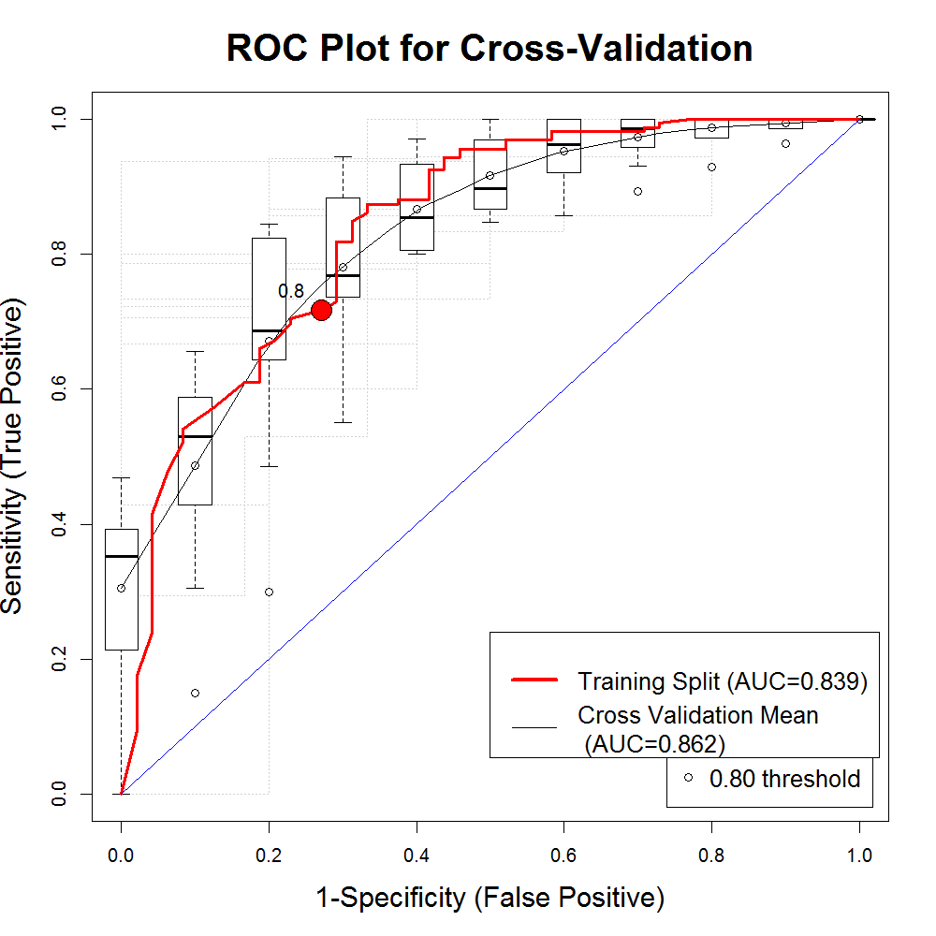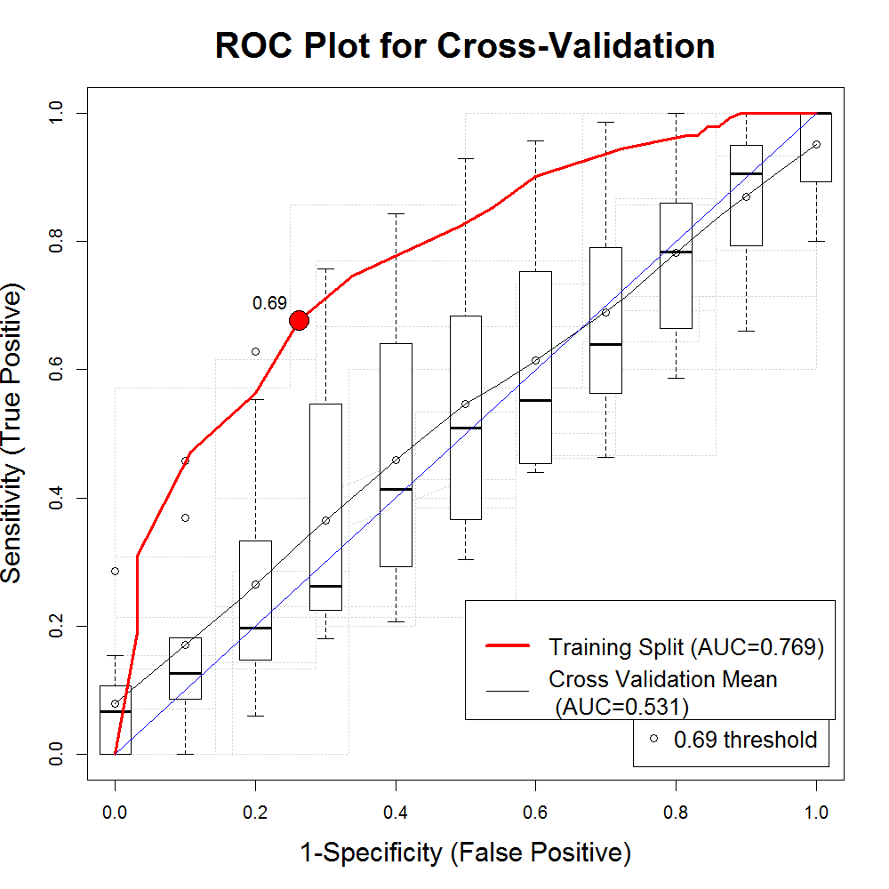

Figure 11. ROC curves.

The graphic on the left shows a good ROC curve in which the curve for data not used to fit the model (the Boxplots for the cross-validation split and line connecting their means) is similar to that used in model fitting, whereas the pattern on the left indicates overfitting by the model algorithm seen in the discrepancy between the Training data and Cross validation split as well as the difference in AUC values. For both of these plots the AUC curve for the Training data looks good it arches far above the diagonal and if we had not included the cross-validation option we might have concluded that both were good model fits.

Examining the ROC curves:

1. Make sure you have worked through the node of the history labeled Brewer’s Sparrow dropping highly correlated predictors and retaining those which explain a high percent of the deviance in the univariate models and continuing processing through model fitting until the spreadsheet is populated. Repeat this process with the Vesper’s Sparrow.
2. When the Spreadsheet view has been populated for both nodes go to the Brewer’s Sparrow tab at the very bottom of the Spreadsheet and click on the AUC tab at the top of the row of non-spatial output. You should see curves similar to those in the bottom row of figure 7 (ROC curves above). How would you describe the model fits for Brewer’s sparrow based on the AUC value? Is there any evidence that any of the models are overfit?
3. Now switch to the Vesper’s Sparrow tab at the bottom of the Spreadsheet view. How would you describe these model fits based on the ROC curves?
4. Now look at the binary maps (the black and white map button under layers in the map panel) and add the presence and absence points to the map. Does the spatial segregation of the presence and absence points give any insight into why the Brewer’s sparrow models have higher AUC values than the Vesper’s Sparrow models?

* The **confusion matrix** shows the number of predicted and observed values in each of the presence and absence classes. The top left box is the number of observations in the specific split of the dataset that was presence predicted as presence and the bottom right is the number of true absences that were predicted as absence. The bottom left and top right boxes are misclassified presence predicted as absence and absence predicted as presence, respectively. These are dependent on the threshold used to discretize the predicted values. The rule used to calculate the threshold is one of the input parameters available in each of the model modules. Several other common evaluation metrics are based on the discretization of the continuous predictions and accompany this plot as text below the matrix. These metrics include percent correctly classified, sensitivity, specificity, Cohen’s kappa, and the true skill statistic.

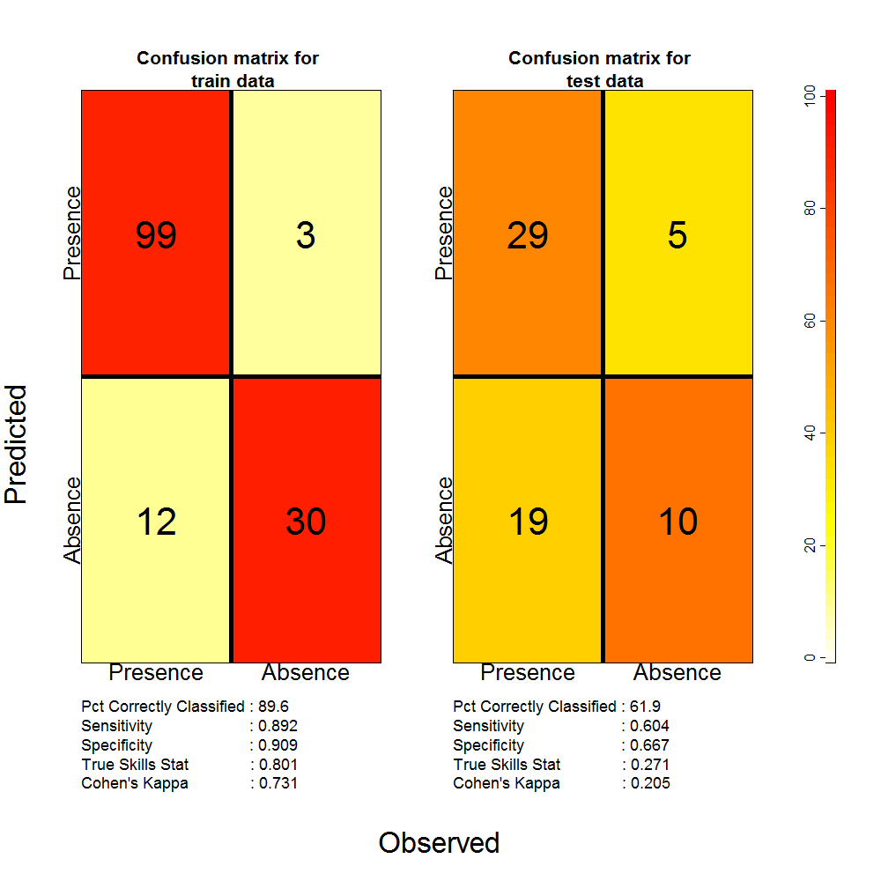

Figure 12. Confusion matrices.

A confusion matrix for a dataset with a test\ training split. The Color scale is based on the column totals so that if all presences are classified as presence and all absences are classified as absence, the diagonal items will be red and the off diagonal will be white. The numbers represent the counts of observations in each category so that the sum of all four elements should equal the number of complete observations in the training dataset that were set aside for training the model and the number for model evaluation, respectively.

Examining the Confusion Matrices:

1. In the model output row of the spreadsheet, switch to the Confusion tab and compare the confusion matrices between the Brewer’s sparrow and the Vesper’s sparrow. Do these plots support your conclusion from the ROC curves about which model fits were better?
2. See if you can calculate by hand the percent correctly classified based on the numbers in the confusion matrix.
3. Sensitivity is the proportion of Presence observations that are correctly classified by the model. Make sure you can calculate one of the sensitivity values based on the cell counts in the matrix as well. Note these will not quite match for a cross-validation split because the Sensitivity and Specificity are calculated separately on each fold and then averaged, whereas the values in the confusion matrix are sums across the confusion matrix for each hold out fold.

* **Calibration plots** and statistics describe the goodness-of-fit between the predicted values and the actual observations. These are especially useful for identifying problems with overfitting or underfitting when separate data is used for model fitting and model evaluation. These plots and statistics can be used to determine how reliably the model will predict if a site is occupied or unoccupied (Pearce and Ferrier 2000). The calibration plot shows the predicted probability of occurrence plotted against a smooth of proportion of occurrence (Philips and Elith 2010). The intercept and slope of this line should be 0 and 1, respectively. The two plots below show a few different patterns that can be identified using calibration plots and statistics. Poor model calibration means that the model predictions do not match well the probability of occurrence at sites. The calibration plot and related statistics are produced for presence/absence and presence-only data. The plots are based on Phillips and Elith’s R code (Phillips and Elith 2010). Depending on your study, it may or may not be important that the predicted probabilities agree well with the proportion of occurrence. If you are interested in the actual probabilities these should be considered, but if only a binary map will be used these are less important because a model with good discrimination (high AUC) can have poor calibration and vice versa (see Pearce and Ferrier 2000 for more discussion on what can be appropriately quantified with models exhibiting either poor calibration or discrimination). We often see positive or negative bias when evaluating a model on a new data set. This would show up as a calibration plot that is systematically above or below the diagonal because our predictions are either systematically too high or low for the new region. It is possible to correct these systematic errors.

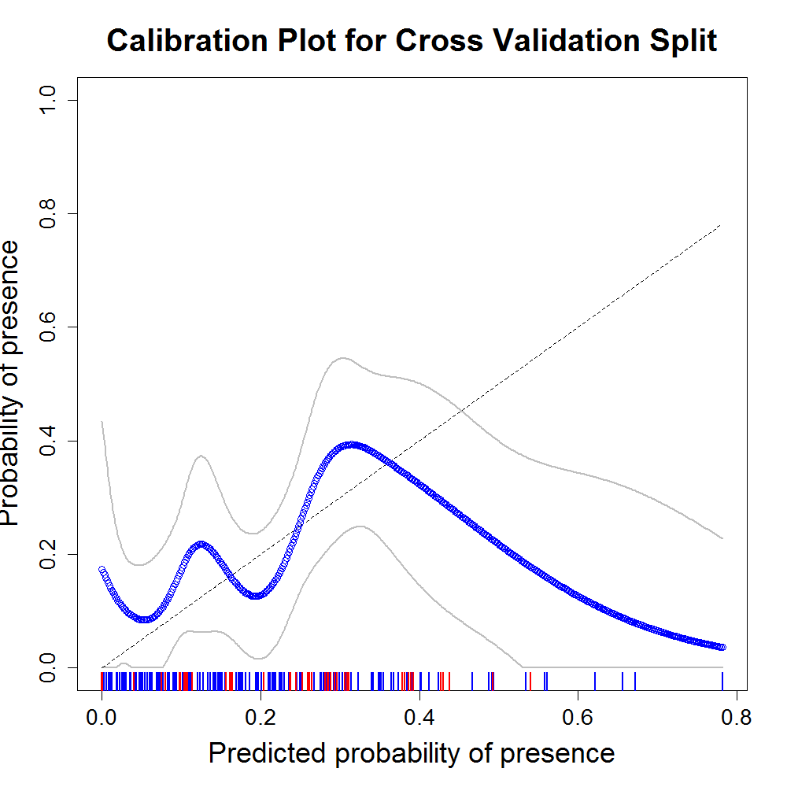 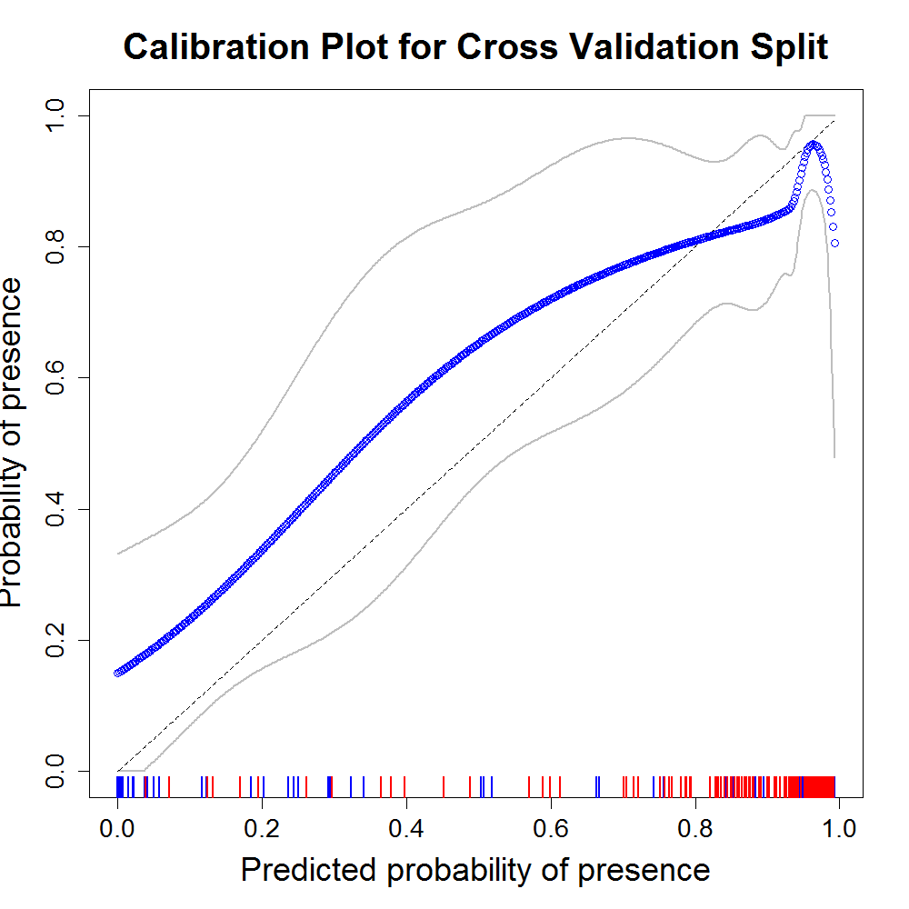

Figure 13. Calibration plots.

Calibration plots from a Sage Thrasher GLM model and a Brewer’s Sparrow MARS model. The model on the left has several absence points (blue rug values) that were given very high predicted values resulting in a calibration curve that doesn’t track the diagonal. The calibration plot on the right tracks the diagonal quite well, indicating good model calibration.

* **Model response curves** show the relationship between each predictor included in the model and the fitted values, while holding all other predictors constant at their means (Response Curves tab in the spreadsheet cell). These curves can be examined to assure that the relationships agree with the biological understanding of the organism under study or that they have an intuitive shape. In general a species will have either a negative or positive response to an environmental variable or a bell type shape where conditions are optimal in a central region between two extremes. Extremely bumpy response curves or those with multiple maxima or minima indicate that your model is overfit. If you see this, you might want to use the parameter exploration tool described in its own section below to select better model fitting parameters as the default values included within SAHM don’t work well in every case. Please keep in mind that these response curves do not take into account interactions between predictors which might have been included in the model and occasionally the response shape can change as another predictor is varied. Each individual response curve can be displayed or an image displaying all response curves for predictors in the model at one time can be displayed by selecting from the drop-down list in the viewer cell.

Comparing Response Curves:

1. In the model output row switch to the Response Curves tab. A drop down menu should appear that will let you select among the predictors that were selected by the model fitting algorithm.
2. Looking at the response curves for Brewer’s sparrow does it appear that the models agree on the relationship between the response for all of the predictors?
3. Minimize the Spreadsheet view and in the history view switch to the Sage Thrasher pipeline. Run this workflow through until the output appears in the spreadsheet. Do the response curves for the Sage Thrasher tell the same story from model to model? Would you be able to give an ecological description of the relationship between the species and the predictors based on these model fits? Later on we will learn to explore the parameters used in SAHM and will hopefully be able to develop a better model for this species.

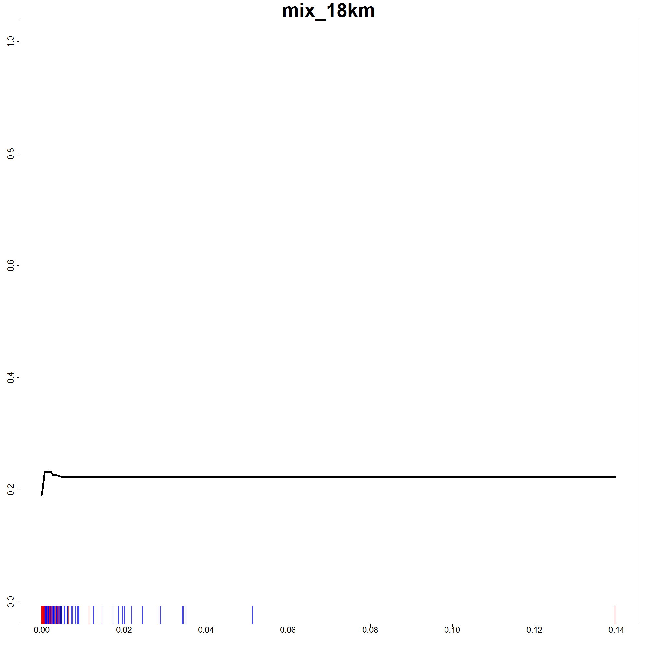 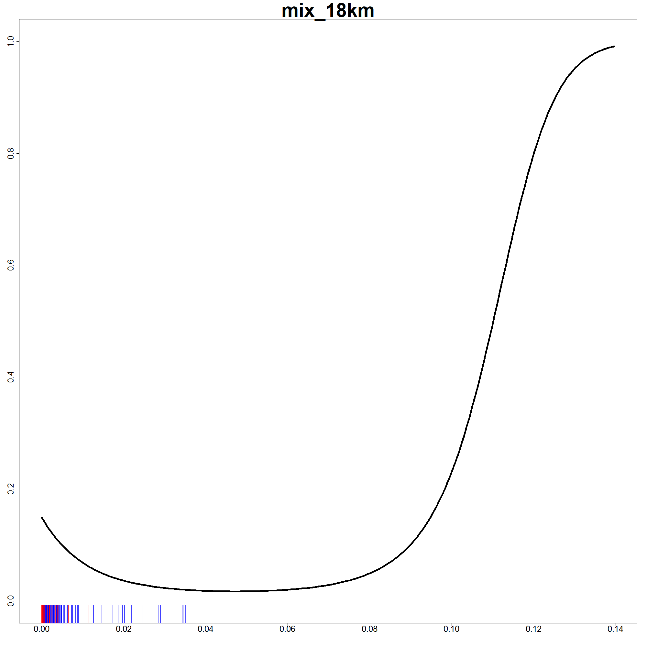

Figure 14. Response curves.

Here are two response curves from the Sage Thrasher models. Notice the rug at the bottom of the plot which indicates the values of the predictor for each presence and each absence observation. You can see that most of the observations were taken where the proportion of mixed shrubland is below .01 and we really have very little data to determine the shape of the relationship beyond that point. If you were interested in the response of the organism to this predictor, then more data would need to be collected in areas with a higher proportion of mixed shrubland. Because of this skew in the predictor and the unreliable fits shown here, maps produced using this predictor will not agree except where the value of mix_18km is very close to zero. Looking at the mixed shrubland layer to determine how much this issue will affect the map would be a critical step.

* Model residual plots show the spatial relationship between the model deviance residuals (Dormann 2007). A deviance residual is a measure of lack of fit for each point when the dependent variable is binary. Most models assume residuals will be independent and identically distributed; thus spatial pattern in the deviance residuals can be indicative of a problem with the model fit and inference based on the fit. It can, for example, indicate that important predictors were not included in the model. Comparison with the spatial pattern of predictors that were not included in the model might be considered. Species-specific processes can also result in spatially structured residuals, in which case more complex spatial models should be considered. Whether or not a significant spatial pattern exists in model residuals can at times be difficult to assess visually. We hope to add correlograms of Moran’s I soon. Unfortunately, statistical tests based on the Moran’s I statistic for residuals of binary response models lack statistical justification and thus cannot be used to test for a significant spatial pattern (Bivand 2008). See Dormann 2007 for more discussion on evaluation of model residuals and spatial models that are appropriate for species distribution modeling. Residual plots can also be used to determine if certain observations contribute disproportionately to the deviance of the fitted model. For a binary response model, deviance residuals with absolute values greater than 2 can be indicative of a problem.

Looking at deviance residuals:

1. Bring up the Residuals map in the bottom row of the sage thrasher tab of the VisTrails Spreadsheet.
2. Are there any noticeable patterns in the residuals?
3. Can you tell if these points were misclassified in the binary map?

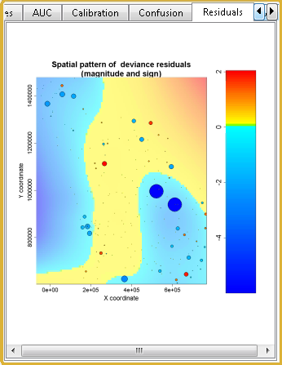 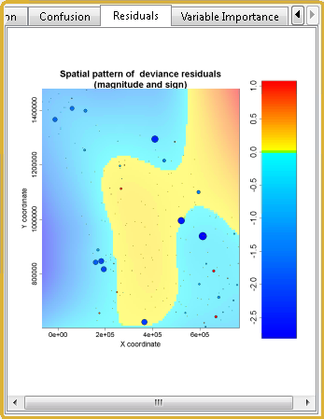

Figure 15. Residuals map.

Spatial patterns of deviance residuals for two Brewer’s sparrow models. In the left panel we see two large clusters of negative residuals in the upper left and lower right. By adding the Coniferous Forest predictor, which better explained the bird distribution, obvious patterns of deviance residuals are much less noticeable.

* Variable importance plots provide a model-independent comparison of the relative influence of each predictor in each model. They are created following the fitting of the final model by successively permuting the values of each predictor in the dataset and then predicting the model to the new dataset with the shuffled (or permuted) predictor values. An evaluation metric is then compared for the predictions based on the unshuffled and shuffled predictor values. If the metric values are very similar then it is an indication that the predictor does not contribute much to the model fit. We measure variable importance using the mean drop in AUC value using five separate permutations of the predictor . A large drop in AUC would indicate that the predictor was important in the model. One important consideration here is that the variable importance is to some extent dependent on the number of predictors used in the model fit. A model with many predictors will show very little drop in AUC when a single predictor is permuted. For extremely bad predictors it is not unusual to see the AUC increase when the predictor is permuted, leading to a negative drop in AUC. Lower importance in test data can indicate that the predictor performed well on the training data but doesn’t generalize well (Phillips, Unpublished).
* The **probability map** is the default map that first appears in the spatial output cell. The probability map is a surface of predicted values produced based on the predictor layers (in tiff format) selected in the CovariateCorrelationAndSelection module and the fitted model. (All models in SAHM except Random Forest have a variables selection process within the modeling fitting). These maps can, but do not always, indicate the probability of finding the species at a given site. If calibration is poor then they might not correlate well with actual probabilities, but rather would indicate relative suitability of locations. Also keep in mind that probability is defined in the sampling design. For example, a probability map might indicate the probability of observing the organism in a 100m patch if monitored for 10 minutes if that is how the presence data was collected. It becomes even more complicated for presence-only studies, where at best this map will be proportional to occurrence.
* A **binary map** is produced by discretizing the probability using the best threshold given the selected threshold optimization method. (The optimization method is a parameter in each model module that can be accessed by clicking the model in the pipeline view; it then appears in the right panel). This map indicates whether one could expect each site to be occupied or unoccupied based on the sampling design.
* The **MESS surface** is the multivariate environmentsl similarity surface and shows how well each location fits into the univariate ranges of the points with which the model was fit. The idea was developed by Elith et al. (2010). Negative values in this map indicate that the point is outside of the range of the training data. The MESS map takes the minimum value of a statistic calculated for each predictor and thus cannot diagnose hidden extrapolation as one might do using a hat matrix in multiple regression. This surface is only calculated for variables that are selected in the model selection step within each model fitting algorithm, so that variables that do not significantly affect the response for the calibration data will not be included in the MESS map even though these predictors might be critical outside the range in which the model was fit. For example if your study region does not cover a large range in average annual temperature this variable would not likely show up in your model. Projecting to a new area with a different average annual temperature would not show up as extrapolation when in fact it is and the average annual temperature could be highly detrimental or beneficial to our organism in a way that our model is not capturing due to this hidden extrapolation. The MoD map is related and indicates which variable was furthest from the range of the observations used for model training. These optional outputs are not produced unless one checks the ‘makeMesMap’ parameter in the model module.

## Creating Curves and maps using expert knowledge (User Defined Curves [UDC])

It is sometimes the case that some expert knowledge about what drives a species’ distribution is available either through the literature or directly from the species experts that are involved in the modeling exercise. Within SAHM it is possible to draw curves based on what is known about the species and then compare these mechanistic models with the correlative models in terms of the maps they produce, their response curves, and/or how well they fit the data. At present all response curves are multiplied together, which means that the predictor with the lowest relative probability will control the modeled probabilities. This also means that when the spreadsheet comes up, the response curves under UDC can be lower, but otherwise identical, from those you initially drew. This is because all other predictors are held constant at their mean to make the predictions from the model, so other predictors can control the highest value in the response curves of the spreadsheet view.

1. In the History view click on the “User defined curves” node and switch to the pipeline. You’ll notice the new model “UserDefinedCurve” has been added.
2. The UserDefinedCurves can be drawn with any of the predictors that were available from the original predictor list while the other models are restricted to those selected at the covariate correlation widget. Execute the model. Once you’ve selected a good set of uncorrelated predictors click ok on the covariate correlation widget and after a few minutes the “User Defined Predictor Curves” tool will pop up.
3. Initially a flat line for each of the predictors selected in the covariate correlation widget is shown but you can click include on any other predictor to get the curve display. There are initially three dots along the curve at the mean and the limits for the available data just to let you know the range of the data under your presence and absence points.
4. The shape of the user defined curves can be changed at any dots on the curve. You can click and drag any dot up and down to change the shape of the curve. In order to add a new dot, double click on the blue line. By default the curve is held flat beyond the last dot rather than continuing on its previous trajectory so you’ll want to be sure to extend your curve out past the last dot if this part of the curve shouldn’t be flat. Clicking and dragging on the canvas allows you to extend your curve past the range of the collected data range.
5. Let’s assume we think that Brewer’s sparrow selects for sagebrush in the summer when our data was collected and that it is less commonly found during the summer in places with an average annual temperature above 8 degrees and that it never found in areas with the average annual temperature above 15 degrees. Given this information we will uncheck “include” for all predictors other than “asage_1km” and “bio1”
6. For Bio1 we’ll draw a curve that starts to slope down at 8 and gradually becomes steeper until reaching a zero probability at 15 (extend the range of the plot by clicking and dragging the canvas). For asage_1km let’s assume that it gradually drops off starting at 40% asage but that the bird can still be found with a low probability of maybe around 40% at 0% sage. Your curves should look similar to figure 17. Click “OK” to continue.

Questions

1. In terms of the evaluation metric how well did we model Brewer’s sparrow with the mechanistic vs. the correlative models?
2. Were the same predictors selected and if so which have more intuitive response curve shapes?
3. Are the probability and binary maps similar for the two models?

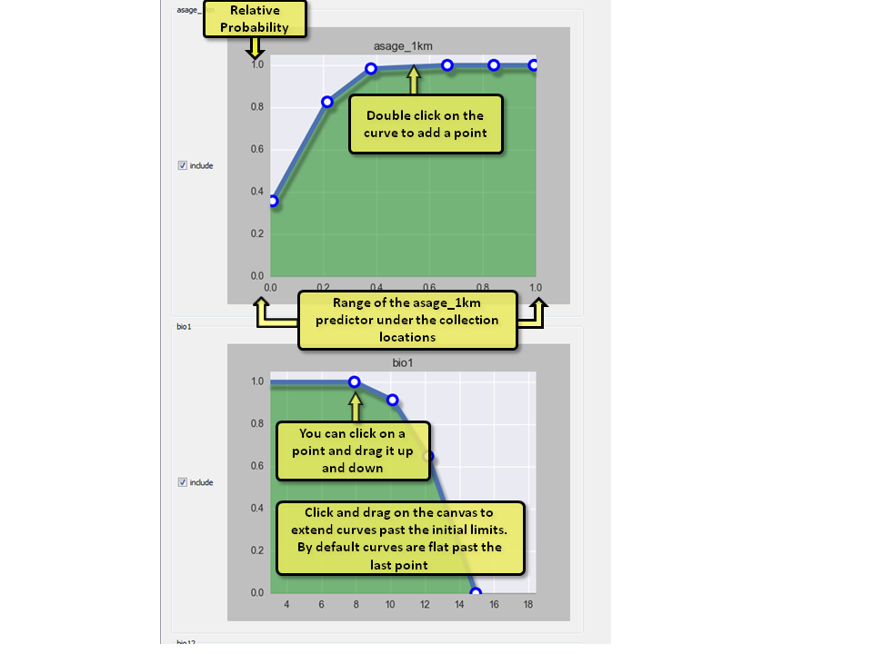

Figure 16. Creating curves from a biological understanding of the species.

## Reviewing everything we’ve learned

For this example we will compare how the models do for Brewer’s Sparrow using the climate predictors vs. the land cover and road density layers. To reduce computational time we will use a test/train split instead of cross-validation and only run two models (GLM and RF) for each set of predictors. Let’s try to output results onto the same spreadsheet tab so that the maps will zoom and pan together. Try to do this on your own, but if you get stuck follow the steps below. Otherwise skip to the questions section below.

Steps:

1. In the history view select the Brewer’s Sparrow Node and then switch to the pipeline view.
2. Replace the ModelSelectionCrossValidation with a ModelSelectionSplit module (under SAHM and then Tools)
3. Delete the MARS and BRT models, but not their Spatial and Model Output viewer modules.
4. Drag a box around the CovariateCorrelationAndSelection module, the GLM module and the RandomForest module to select these three modules. Copy these and paste them into the canvas.
5. Connect the new GLM and Random Forest modules to the Spatial and Output viewer modules from the deleted MARS and BRT models.
6. Connect the new CovariateCorrelationAndSelection module to the ModelSelectionSplit module.
7. In order to avoid confusion we’ll name the runs so we can tell landuse from climate in the output drag in two OutputName modules from under tools and change the run_name to “Landcover” in one and “Climate” in the other.
8. Go back to the history view and give an appropriate name to this new node.
9. Back in the pipeline view, hit execute. When the first CovariateCorrelationAndSelection widget comes up, deselect any layers that start with “bio” and then filter out any of the remaining predictors based on their correlations and their % deviance explained values. Hit ok to continue.
10. When the second CovariateCorrelationAndSelection widget comes up, deselect any layers that *do not* start with “bio” and then filter out any of the remaining predictors based on their correlations and their % deviance explained values. Hit ok to continue.

## Questions:

1. How do the probability and binary maps compare using the two sets of predictors?
2. How would you rank the model fits based on the evaluation metrics and graphics described above?
3. Would you say any of the models are overfit based on the response curves? Is this conclusion supported by other graphics?
4. Which variable is most important for each model (note if only one variable was selected this plot is not produced)?
5. cfrst_18km (Coniferous forest) was highly correlated with bio13 and bio12 (Precipitation of the wettest month or annual precipitation). Do you have any thoughts on which of these the Brewer’s sparrow is responding to?

## Presence-Only Modeling and Related Tools (Maxent)

It is important to note that presence-absence models are preferred to presence-only models (Elith et al 2006) so when absence data are available it should be used. While the information contained in the location of observed absence is valuable, it is not always available and modeling with presence only data is unavoidable. For the purpose of illustration, we will remove the absences from our dataset and demonstrate how one would model with presence-only data by generating background points (sometimes referred to as pseudo-absence).

Steps:

1. In the history view select the presence ONLY modeling (with Maxent) and switch back to the Pipeline view.
2. What differences do you notice between this workflow and the presence/absence workflows we’ve be working with so far? (hint: it will probably be hard to identify looking at the pipeline itself. Instead go back to the history view and drag the ‘presence ONLY modeling (with Maxent)’ onto the ‘Brewer’s Sparrow’ node.)

Notice the following:

* 1. The most obvious change is the addition of the Maxent module to the list of models used. Maxent is a presence only model so wasn’t include in the last workflow.
  2. Presence only models require background points. While the Maxent tool can generate these itself we’re going to generate them in SAHM so that all the models can use the same point locations. To do this we specify 10000 as the backgroundPointCount in the MDSBuilder. To get these points to have a spatial distribution similar to that or our presence locations we’re using a BackgroundSurfaceGenerator which generates a Kernel Density Surface from our presence points.
  3. The other changes in the workflow are fairly inconsequential and include using the FieldDataQuery module to drop the absense points, changing the output folder name with the OutputName module and converting from a cross validation split to a test training split to speed up processing.

1. Exit out of the Diff view and execute the workflow. Make appropriate selections when the CovariateCorrelationAndSelection widget shows.
2. Notice that the Maxent application will popup while it’s running.

**Questions:**

1. How do these model output compare to the original Brewer’s Sparrow output?

## Options for Selecting Background Points

With presence-only data there is often a bias in how the data were collected. For example, sampling efforts will generally be disproportionately near urban areas or roads. When models are fit to such datasets without consideration of this issue it is impossible to disentangle the degree to which you are modeling the species habitat and the extent to which you are modeling the sampling process (i.e. where people look for the species). Unfortunately, it is very difficult to quantify these biases. The preferred approach in this situation is to use sample locations from species in the same species group as the background points for your study(Elith 2010). When sample locations from other studies are not available we are left with the option to explore how uncertainty regarding the sampling might affect model output. For this reason we have incorporated several options to create surfaces from which background points can be generated that use a variety of assumptions about what the sampling effort might have been. Aside from the random placement of background points, other options require a background probability surface which can be generated from your presence points using the BackgroundSurfaceGenerator. It is also possible to use another grid layer that has values from 0 to 100 if external information is known about the sampling bias. When using your own layer for this, make sure the projection, extent, and cell size match your template layer.

**Exploring options for background point selection methods.** A subset of the presence points we’ve been modeling with has been extracted to better highlight the differences in these options.

Steps:

1. In the history view select the ‘Explore BackgroundSurfaceGenerator options’ node and switch back to the Pipeline view. Click execute.
2. Don’t worry about the specifics of this workflow it is just for visually displaying the background point selection methods available in SAHM and does not represent a typical SAHM workflow.
3. In the spreadsheet that results the green dots are our presences, black dots are our background points and the blue to red color ramp on the right four cells is the probability of a random point in that cell being retained.
   1. The upper left cell is the template with random points placed throughout the entire study area defined by the template.
   2. The middle upper cell shows points placed within a minimum convex hull around all the presence points.
   3. The right upper cell shows a 95% isopleth contour on the kde of the presence points.
   4. The lower middle shows an 80% isopleth contour on the kde.
   5. The lower right shows random point placement according to a continuous kde surface.
4. Note that in all cases nodata areas in the template will not have random points.

**Questions:**

1. Notice that there are no presences in the Northwest portion of our extent. If this area was not actually sampled but the species was present there, which of these methods would give the best model?
2. What if that area had been sampled but the species had not been found? How could you tell the difference between these two cases?
3. Go back to the presence ONLY node we just ran. Re-run this workflow with an MCP background surface generation method. Hint, you’ll also want to change the OutputName subfolder_name, and rename the node in the history so that the outputs can be compared to the original version. Did changing the background point placement method change the model output?

## Applying a model to a new region

SAHM has the capability to save a model and apply it to a new spatial or temporal extent. Please note that there are important caveats that apply when projecting models to completely novel areas or to different temporal ranges. The workflow should not be undertaken without a good deal of consideration regarding the various sources of uncertainty and bias (see Beale and Lennon 2012 and Diniz-Filho et al. 2009 for a discussion of the sources of uncertainty and a method of modeling in the face of large uncertainties). On the purely technical side, to do this we have to line up our new rasters. The new rasters must match the original rasters in name (e.g. bio1), but could be for a new location or time. You will need to specify a template for setting the extent, projection, and the mask and then provide the ApplyModel module with this raster information as well as the information from the model we would like to project.

While the pipeline to apply a model to a new extent can at first appear a bit complex it’s fairly straightforward. The original pipeline is the basis for the new workflow. To this we add another set of predictors, TemplateLayer, PARC and MDSBuilder. If the area is the same but we’re applying to a new time period the template used might well be the original temple. If we’re applying the models to a new spatial extent the template will define the new extent. The list of predictors must be named identically to the original predictors (if there was a Bio1 in the original model there must be a Bio1 in the new covariates) but the new predictor grid will cover a new spatial or temporal domain. The MDSBuilder in this case is just used to format the list of inputs into the format expected by the ApplyModel module.

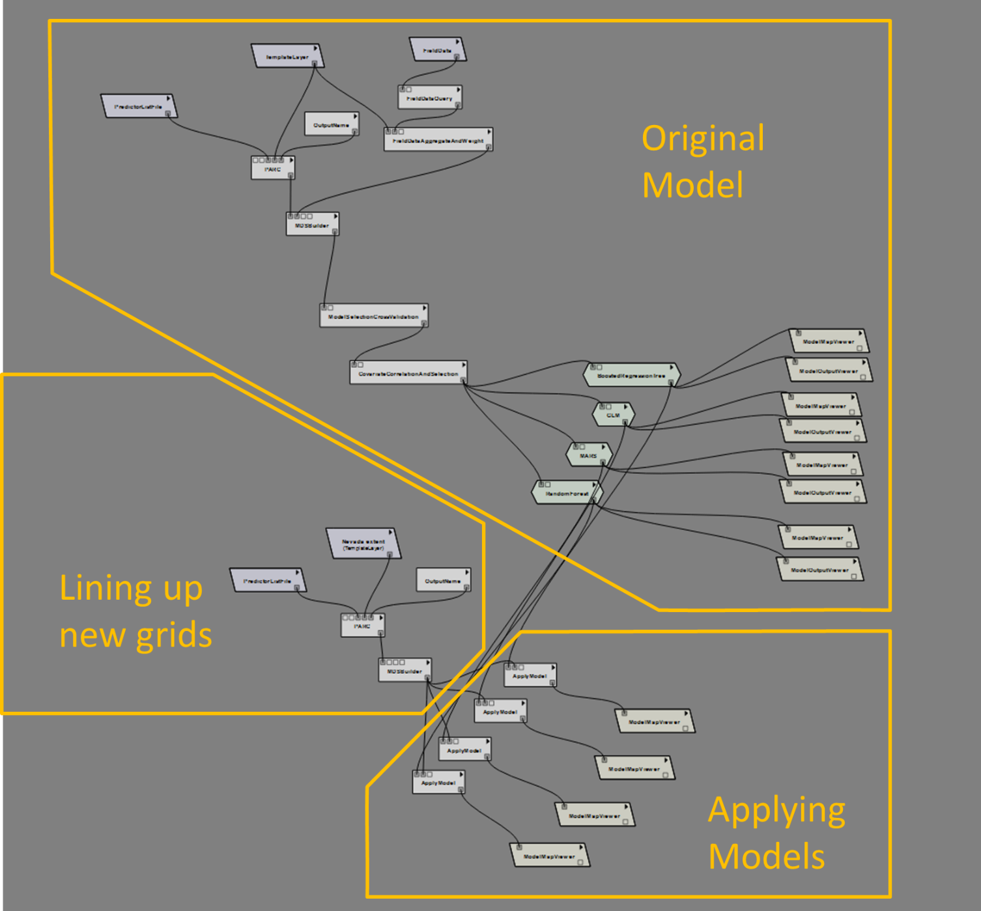

Figure 17. Applying models to new spatial or temporal domains.

**Applying our Brewer’s Sparrow model to Nevada.**

Steps:

1. In the history view select the ‘Apply Brewer's to Nevada’ node and switch back to the Pipeline view.
2. Identify the parts of the workflow that correspond to the sections identified in figure 17.
3. Notice that the predictor list file used for the original model is used again below to specify the raster layers to apply the model to. These layers cover all of the continental US so by specifying a new template we can change the extent of the PARC output. This list of predictors does not include the landscape metrics we used in the BrewersSparrow node of the tutorial. This only because we do not have these metrics for Nevada but they could and probably should be obtained.
4. Execute the workflow, select appropriate covariates, and wait for all the models outputs to appear on the spreadsheet.
5. The models in this workflow have the optional multivariate environmental similarity surface (MESS) and a map of which factor is limiting at each point (MoD) output selected. These layers can be helpful in identifying areas of the output in which we’ve extrapolated beyond the values we fitted the model for.

**Questions:**

1. Turn on the Mess spatial output by clicking the purple and green icon in the map toolbar. How much have we extrapolated in this new region?

## A short digression into climate models

There is a steep learning curve with understanding climate model projections and all of their idiosyncrasies. We will only be able to cover the tip of the iceberg here but a brief explanation of what we are doing in the node applying models to future conditions is in order. The Maurer 1/8th degree data set is the gridded historic dataset that we use in this tutorial (Maurer 2007). There are several gridded historic datasets available. These are generally based on weather station data that has been interpolated to provide continuous spatial coverage. These gridded historic products do not agree for all areas or time points because of the differences in the interpolation methods and sources of information they use. This is especially true for areas far from weather stations and/or climatologically complex areas such as in the mountains, near coasts, in the west (see Oyler 2015 for example). For our SAHM tutorial study region the most commonly used interpolated climate datasets (PRISM, Maurer, and TopoWx) do not agree for all variables; see figure 18 which shows historic trends. This can have important implications for how you project onto future climate.

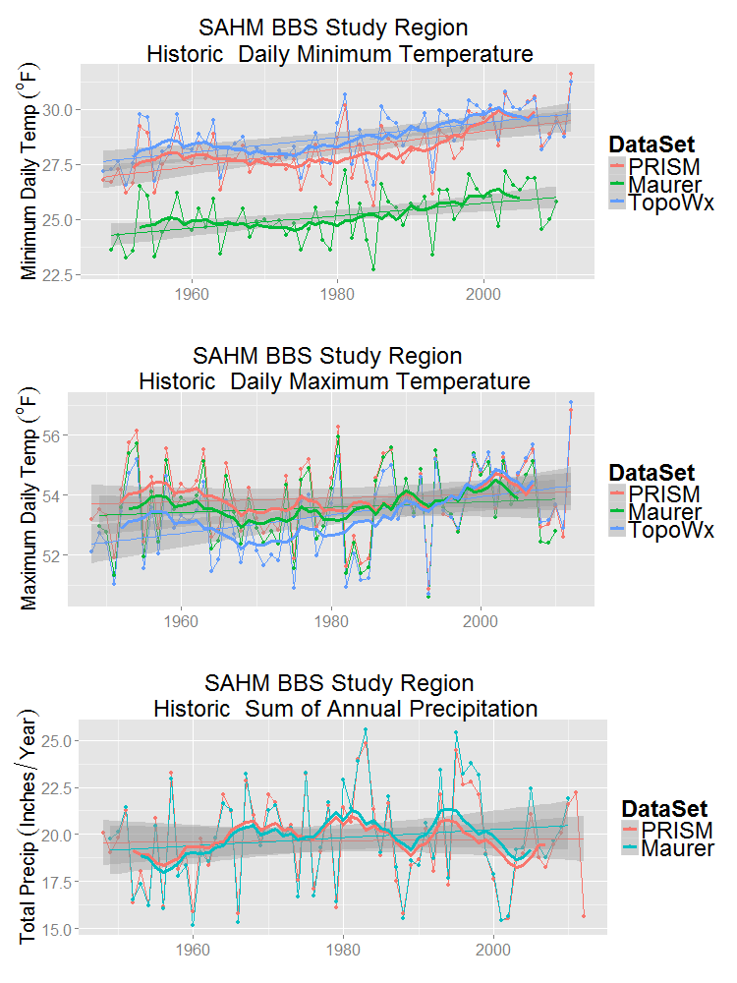

Figure 18. Annual historic line plot comparing TopoWx, PRISM, and Maurer. We have added linear models with their 95% confidence intervalsas well as a 10 year rolling average.

In addition to gridded historic products there are also climate models that project potential future conditions based on various assumptions. The most recent round of climate model projections is CMIP5 (Coupled Model Intercomparison Project; Stocker et all 2013). Several modeling groups from around the world ran Global Climate Models (GCMs) using four sets of assumptions about greenhouse gas forcings which can be thought of as possible paths we could take for greenhouse gas emissions into the future. It should be noted that these four paths do not encompass all possibilities regarding future greenhouse gas emissions. The emissions pathways are called Representative Concentration Pathways (RCPs). The numbers associated with each RCP represent the radiative forcing values in 2100 relative to a pre-industrial time period thus 2.6 is the most optimistic about future carbon emissions, followed by 4.5 and 6.0. RCP 8.5 assumes the highest levels of carbon dioxide emissions and thus the steepest change in future temperature. Using these emissions pathways the various modeling groups ran models projecting future climate. The original model output comes in a very coarse resolution (1 degree). These datasets can have severe biases for any specific study region because the modeling goal is to represent the physics well rather than to match the climate over the historic period exactly for every given time period and location. Because of the coarse resolution and the sometimes severe regional and temporal biases, these models are generally downscaled and bias corrected using one of several possible methods. This forces the models to agree with a specific gridded historic dataset such as PRISM or Maurer over the bias correction period and usually removes the most prominent biases and provides output at a scale more useful to ecosystem modelers. The various bias corrected downscaled products can have large disagreements over certain regions and for certain variables because of the differences in the downscaling method or because the observational datasets used for bias correction differ, as described above. We use the CMIP5 BCSD 1/8th degree dataset available from the Green Data Oasis in the tutorial for considering potential future conditions. This dataset was bias corrected using Maurer 1/8th degree so the model projections should agree well with our gridded historic dataset over the bias correction period.

Once you have determined an appropriate historic dataset and set of models for projections then one must decide on a set of models in the CMIP because it is generally too time consuming to project onto all available models. Given the large amount of uncertainty about future conditions it’s generally advisable to select models that bookend the projected ranges for change in precipitation and temperature. Others might advise selecting models with low biases in your region of interest over the historic period. We chose to select models that capture the range in projections under RCP 4.5 and RCP 8.5 for our study region; see the below figure.

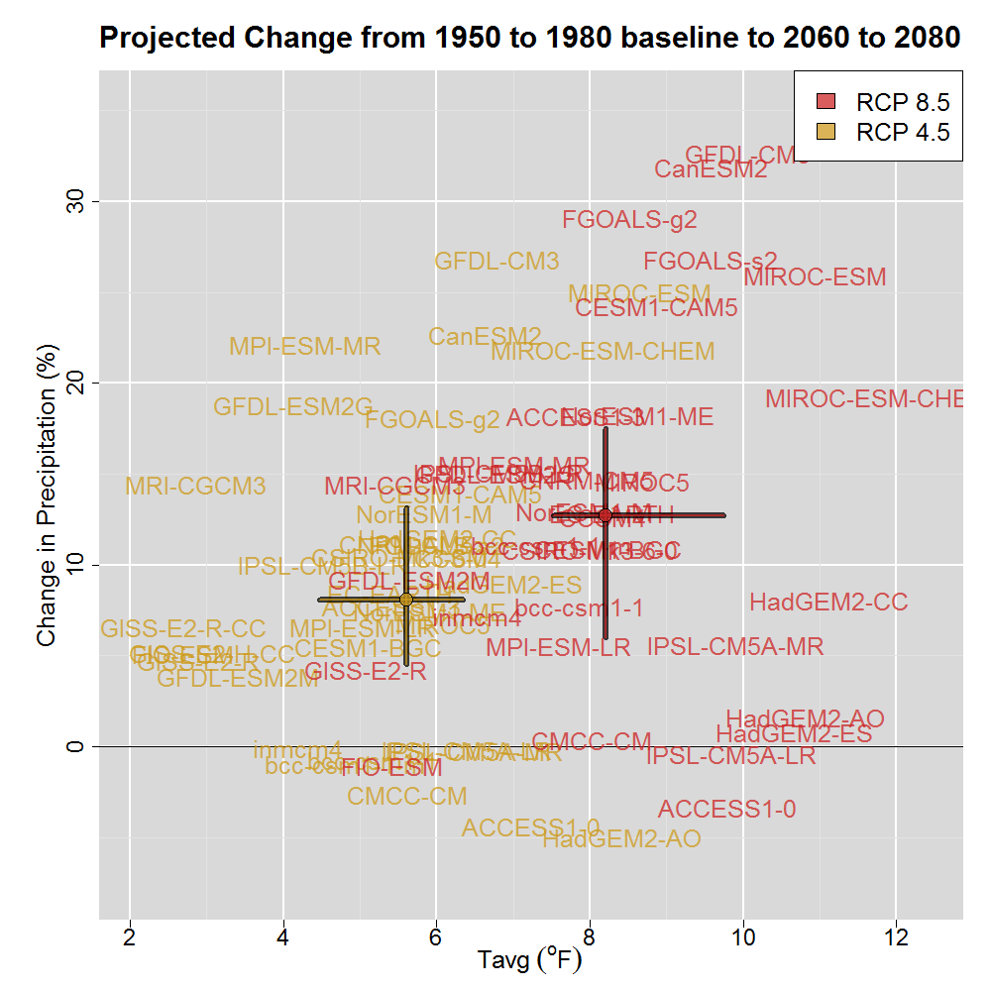

Figure 19. Scatterplot shows the projected change in average temperature and the percent change in precipitaton from a baseline period of 1950 to 1980 to the future period 2060 to 2080 for our study area. We have put boxes around the models we are using in this tutorial.

The delta method is one of the most straightforward ways of assessing the potential impacts of climate change. This method avoids the potential for biases that can arise when projecting the model calibrated using gridded historic data directly onto a GCM forecast. To use the delta method we estimate our model using the Maurer observational dataset for the years of data collection (2000-2005). For each temperature covariate, we take the average of GCM projections for a future time period (2040-2060) and subtract the average GCM historical projection over our study time period 2000-2005; this difference within the GCM in the modeled past and the modeled future is termed the ‘delta’. For example, if the GCM projected that average of mean annual temperature was 20 degrees C during 2000-2005 and 22.5 C during 2040-2060 our delta would be 2.5 degrees. This delta can be calculated for each grid cell of our climate data. For temperature, we would add this projected change to the Maurer 2000 to 2005 data. For precipitation, we would calculate the delta as the ratio of GCM future and past precipitation, and then multiply it to the historical value. Note that when the time period used for model estimation is not the same as the time period used for bias correction, the GCM historical value and the gridded data historical value can differ. It is generally recommended that a 30-yr (or longer) time period is used for summarizing climate data, including data from GCMs, because annual and decadal variation can dominate at shorter time scales. However, if there is a significant trend in the historic data, the mean over a 30 year period will differ from the mean over the shorter 5 year period used for model estimation. This can effectively lead to a difference in the magnitude of projected climate change (Fig. 20). We recommend estimating models with historical data from the temporal period that makes the most sense for the focal organism and time frame of data collection. It is wise to compare the values of the climate covariates from the gridded historical data used in model estimation to the GCM historical simulations used as a baseline for the delta method. In this example, we proceed with using a 5-year time period as a baseline. For users beginning to explore the potential effects of climate change, we note that a useful first step in any climate change impact assessment is to conduct a simple sensitivity analysis by generating predictions based on spatially uniform changes in climate (e.g. a 2 degree C increase in temperature and/or a 10% change in precipitation).

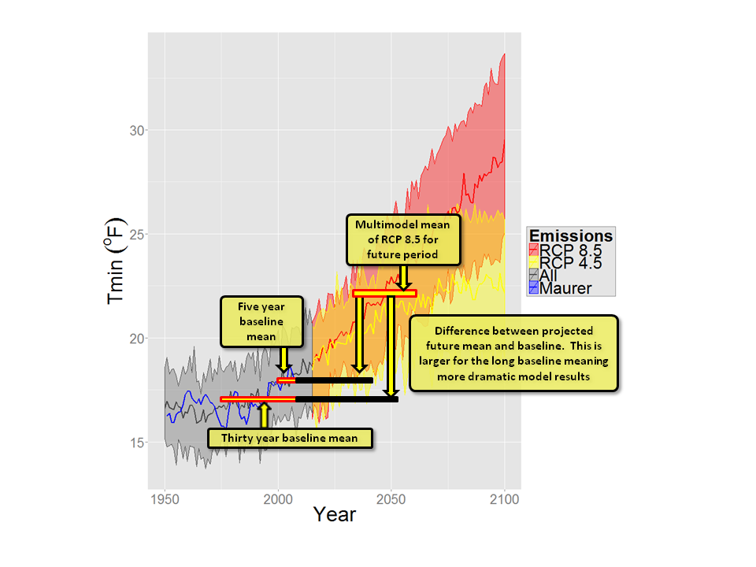

Figure 20 Problem with using a long baseline period when your data was not collected during that long period

## Applying a model to future climate projections

As in the previous section, SAHM has the capability to apply a model to new time range. The same caveats that apply when projecting models to novel spatial extents are just, if not more, important when applying a model to projected climate. The same workflow that was used to apply a model to a new spatial extent is used to apply a model to future climate data by changing the input layers to point to layers that correspond to the covariates used in the original model but calculated from downscaled general circulation models (GCMs). With future climate projections it is possible to find novel climate conditions for which there is no current analog. Additionally ancillary covariates that can be important predictors of current habitat suitability (road density for example) might be unavailable or unreliable for future projections. Another consideration when applying to future climate projections is the importance of capturing some of the variability in the future projections by applying the SDM to climate data from multiple GCMs using the method discussed in the previous section (i.e. selecting GCMs that cover the range of future projections). Alternatively, using at least 10 GCMs has been advised to adequately sample the climate space represented by the full ensemble of GCMs. It is important to note that when an ensemble is desired, the species distribution model(s) should be used to generate predictions under future projected climatic conditions, and these results can then be summarized to capture both the central tendency and range of variation. It is not advisable to average output from multiple GCMs before generating predictions from the distribution models, as this undermines the physical relationships between climate variables in each GCM and can lead to unrealistic correlation patterns.

**Applying our Brewer’s Sparrow model to future conditions.**

Steps:

1. In the history view select the ‘Apply Brewer's to future climate’ node and switch back to the Pipeline view.
2. Identify the parts of the workflow that correspond to the sections identified in figure 17. Notice that the bottom two sections are repeated three times here, once for each of three GCMs.
3. Notice that the predictor list file used for these new apply models are different from the ones we used above. They now point to files with projected climate 60 years in the future.
4. Execute the workflow, select appropriate covariates, and wait for all the models outputs to appear on the spreadsheet.

**Questions:**

1. Do these models demonstrate more or less extrapolation than the apply model to Nevada example?
2. Is there more agreement between SDMs or between GCMs when projected onto future climate conditions?
3. Based on the evaluation metrics do we fit worse models when using only the climate variables (hint: compare the output metrics from these models to that from the original brewer’s sparrow models)?

## Applying a model to independent evaluation data

The best test of a model comes from applying it to a completely independent data set. When these are available we can set up the workflow to fit the model on one set of data and evaluate it on the new dataset to produce unbiased evaluation metrics. We have set up a node called IndependentLocation in our workflow to demonstrate how we can evaluate the models developed using the breeding bird survey data on an independently collected dataset from the Sagebrush Ecosystem Conservation and Management: Ecoregional Assessment Tools and Models for the Wyoming Basins website (<http://sagemap.wr.usgs.gov/wbea.aspx#CAdata>).

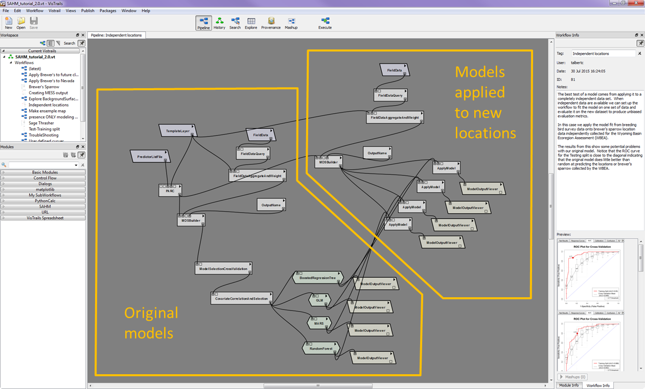

Figure 21 This figure shows a workflow set up to evaluate a model fitted using one dataset on a new dataset. In the first box we perform the normal operations to fit our model. In the lower box we use the MDSBuilder to build the mds file which aggregates our input layers with the new locations and responses. Apply model is used to apply our original model to the new dataset.

**Applying the model to independent data.**

Steps:

1. In the history view select the ‘IndependentLocations’ node and switch back to the Pipeline view. Hit execute to run the workflow.
2. When the spreadsheet view comes up you will see in the top row the evaluation metrics using the training data as well as those produced using data splitting and in the bottom row the evaluation metrics using the training data as well as those produced with the independent data.

**Questions:**

1. How do evaluation metrics compare using data splitting versus independent data?
2. What might be some causes for the steep drop in evaluation metrics?

# Parameter Exploration and Tracking model performance

The models in SAHM have several parameters for which there is either a hard coded default value or an internal method to attempt to optimize the parameters if a specific value is not explicitly set by the user. If the default parameters for a model are not producing a good fit for the data, there is an option in SAHM for exploring other values of parameters that might improve the model fit.

Parameter Exploration

For this example we will explore two parameters for the BRT model to see if we can improve on the default model fit.

Steps:

1. In the history view select the Test-Training split node which uses the Brewers Sparrow data but will run quicker than cross-validation as it fits one model rather than 11 models.
2. In order to make the model fitting run quicker we will not produce maps as we explore parameters. Switch to the Pipeline view and click on the BoostedRegressionTree module. Expand and uncheck makeBinMap and makeProbabilityMap.
3. Delete the GLM, MARS, and RandomForest Modules, all of their attach output viewers, and the ModelMapViewer attached to the BoostedRegressionTree module.
4. To keep our outputs organized we want the output from this exploration to show up in a new folder, so in the OutputName module change the subfolder_name to “brewersSparrow_PE”.
5. Go into the history view and name our new node.
6. Next we will move to the Explore view (right at the top near history, pipeline, and execute)
7. In the Pipeline Methods panel on the right, check the box “Show Unset Parameters” in order to see all the parameters for the modules.
8. On the right of the canvas you will see a list of input values that can be explored for each module. Drag in the NumberOfTrees and LearningRate
9. For both of these we’ll use a list, so in the central panel under the two parameters we just dragged in, to the right of the two boxes for values you will find a black arrow. Click on this and select “List”. For NumerOfTrees enter [10, 100, 500, 1000, 5000] and for LearningRate enter [0.2, .01, .001, .0001]
10. So that the output shows up in a new cell increase the number of columns to 5 and number of rows to 4. Make sure Learning rate is going to rows and NumberOfTrees to Columns. Your screen should look like the figure below.
11. Click execute.
12. After selecting the covariates and clicking OK, a new model will execute for each combination of the parameters we selected.
13. Once all of these models turn to orange in the Running Jobs list that will pop up click execute on the parameter explorer again to see the results.

Questions

1. Based on the AUC for the testing split which model would you select?
2. Would you select the same model if you were considering the bumpiness of the response curves?

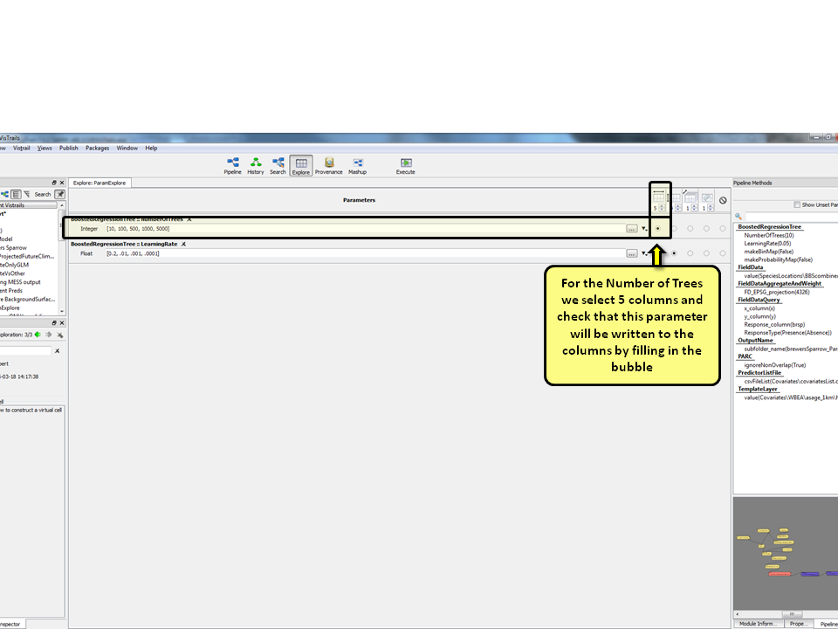

Figure 22. Parameter exploration setup

# File management in SAHM

You may have noticed while going through this tutorial that SAHM has the potential to produce copious quantities of files and directories in your session folder. Even with the provenance capture and caching built into VisTrails it is easy to lose track of which output corresponds to which model run. In order to make management of these outputs easier, we have added the ability to name individual output files and organize them into subfolders. This is accomplished through the use of the ‘OutputName’ module which you might have noticed in most of the tutorial workflows. This module allows you to specify a tag which will get inserted into output file or folder names. The ‘OutputName’ module can be connected to most of modules found in a typical workflow including: FieldDataQuery, FieldDataAggregateAndWeight, BackgroundSurfaceGenerator, MDSBuilder, etc. Note that you don’t need to connect the ‘OutputName’ module to each model in a workflow as all models downstream of the one the ‘OutputName’ is connected to will honor the last names specified in the last upstream ‘OutputName’ module.

For example all of the outputs from a boosted regression tree model will get saved into a folder called brt_1 in your session folder. The next time you run brt with different inputs or parameters the output will go into a folder called brt_2. If you have an ‘OutputName’ with a ‘run_name’ of ‘PresenceOnly’ anywhere upstream of the BRT module, the output will go into a folder called brt_PresenceOnly_1. In addition to specifying a ‘run_name’ you can also specify a subfolder name which will cause all subsequent output to be saved into a named folder within your session folder. You can specify both a ‘run_name’ and ‘subfolder_name’ or either individually.

# Running Models with your own data

## Gathering your Data

In order to run models with your own data you will need the following input data. More detailed information about each of these can be found in the SAHM user guide.

1. A Field Data file: a .csv file which contains X and Y coordinates and a response column. The response can be presence, presence/absence, or count. You must know the coordinate system/projection/datum the x and y are in. The exact formatting of this file is flexible as long as it is in CSV format and the data are arranged in columns. You can use the FieldDataQuery module to reformat it into the format expected by the rest of the workflow.
2. A series of geospatial raster layers: These must cover the extent of your field data locations. Many common raster formats are supported including geotif, ascii, image, and ESRI grids. While these do not need to be in the same projection, datum, or resolution, they all must have defined projections. Some unusual projections might cause problems in the automatic reprojection and resampling algorithm used in PARC.
3. A Predictor List File: a .csv file containing a list of the locations on your computer where the rasters corresponding to each covariate can be located, whether they are categorical, as well as a few other optional resampling details that are discussed in the user guide. Alternatively you can specify these directly in VisTrails by using individual Predictors modules.
4. A Template Layer : a raster which is used to define the spatial extent, resolution, and areas to be masked out in all subsequent analysis. This raster must have defined projection information.

## Starting a new VisTrails VT file

While it is possible to construct a complete workflow from scratch on a blank canvas, we have found it more efficient to use an existing workflow as a starting point or template. The history nodes in this tutorial can be used as such. Since you will not want your new VisTrail file to be cluttered with the extraneous history present in this tutorial create a new, blank VisTrail file by clicking the ‘New’ icon in the upper left or clicking File->New. You will notice that the canvas is now blank and a new VisTrail file named Untitled.vt appeared in bold under your ‘Current Vistrails’ pane. Click save and select a meaningful file name and location.

Now we will populate the initial node of this new Vistrail using one of the history nodes of the tutorial vt as a template. Select the SAHM_tutorial_2.0.vt from the Current Vistrails pane and select the History view. Select the node in this workflow that most closely matches the modeling you are going to be doing. For example, if you have presence-only data select the node called ‘Brewer’s Sparrow Presence Only’. Switch back to the Pipeline view. Now select all the modules and connections on the canvas by drawing a select box around them (click and hold the left mouse button towards the upper left of the canvas and drag to the lower right). Alternatively you can select everything with a ‘Ctrl-a’. Copy the selected items with a ‘Ctrl-c’. Now select the Vistrail you just created by clicking it in the Current Vistrails pane. Click in the canvas and paste your copied modules with a ‘Ctrl-v’. The above technique can also be used to move portions of workflows between history nodes and different Vistrails.

Now that we have a template to work with we can modify it to our data and run it. Point the PredictorListFile, TemplateLayer, and FieldData modules file parameters to your specific versions. Change any other parameters that your model requires. For example Response_column, x_column, and y_column in the FieldDataQuery will likely need to be modified. Click execute and if everything is set up correctly your models will run correctly. Switch back to the history node and label the last node with a name and notes of your choosing. From here you will be iteratively modifying this workflow and examining the output in a process similar to what we have done in the tutorial example above.

# Trouble Shooting

As with any complex piece of software there are a myriad of problems that can arise when using SAHM. Some of these are actual software bugs, but many are the result of various user errors or unanticipated (and thus not handled correctly) combinations of inputs and parameters. For many of the more common errors we have added checks that return a sensible message to alert the user what has occurred and what to do to fix it. Examples of this type of error include pointing to files that do not exist, malformed or nonstandard files, spatial data that does not have a defined projection, and specifying nonsensical parameters. When a workflow encounters one of these problems execution stops and the module that encountered the problem turns red. Hovering over the red module will display the error message as in figure 12.

In order to demonstrate this in a controlled manner we have added a node to the tutorial workflow to walk you through fixing errors. Click on the troubleshooting node and click Execute. Try to identify and correct the introduced errors. Hint: the workflow is the same as ‘Presence only using the entire study area’ with three introduced errors.

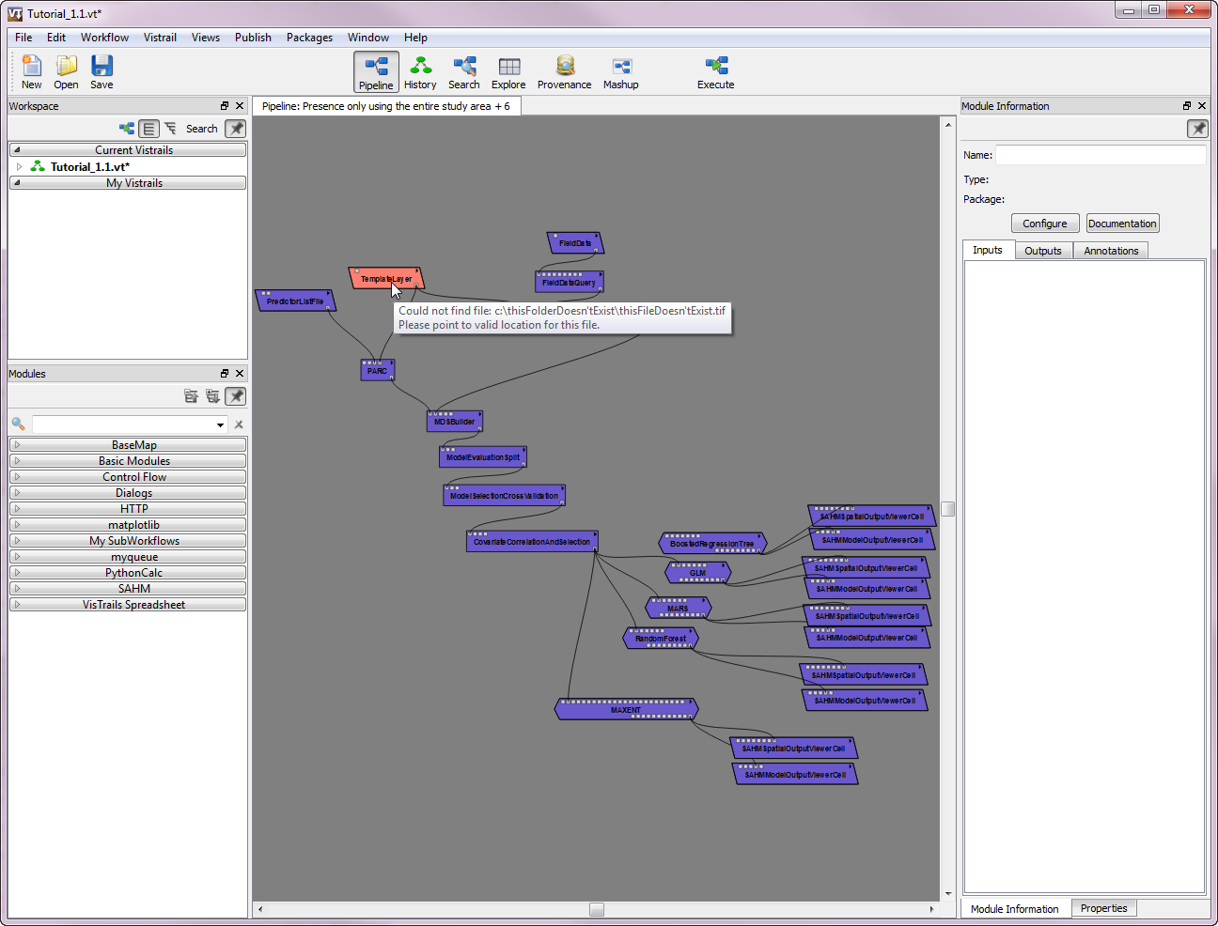

Figure 24. An error encountered in a module and the corresponding error message.

Although many errors can be identified in the process described above, many require much more in depth investigation. In order to assist with this type of troubleshooting, we have included a series of log files in the output session folder. At the root of the session folder is a file called ‘sessionLog.txt’ which contains a detailed recording of exactly what was run and when, the command lines used to run external processes, error messages, etc. Additionally, the standard output and error generated by external processes is captured in separate text files. At the root of the session folder is one called errorLogFile.txt, and within each individual model folder (e.g.. rf_1, mars_2, etc.) you will find stdErr.txt and stdOut.txt. These can sometimes be used to deduce the problems and possible solutions.

As with most open source software projects the developers of SAHM are not funded to provide assistance to users of the software. When encountering problems using SAHM it is up to the user to investigate the issue fully themselves. This includes reading the built-in documentation and the user manual, comparing the problem workflow and inputs to those provided in this template, and searching previous posts to the user group. If the problem remains unsolved the user should post the problem to the SAHM Google group (<https://groups.google.com/forum/#!forum/vistrails-sahm>). Other users and the developers will respond to these posts as able. As a last resort, and only concerning true bugs in the software should a user contact the developers of the software.

# References:

Baddeley, A. and Turner, R. (2005). Spatstat: an R package for analyzing spatial point patterns. Journal of Statistical Software 12 (6), 1-42. ISSN: 1548-7660.

Beale, C., and Lennon, J. (2012) Incorporating uncertainty in predictive species distribution modelling. *Phil Trans. R. Soc*, 367, 247-258.

Bivand, R.S., Pebesma, E.J., and Gόmez-Rubio, V. (2008). Applied Spatial Data Analysis with R. Springer New York, NY.

Diniz-Filho, J. A., L. M. Bini, T. F. L. B. Rangel, R. D. Loyola, C. Hof, D. Nogue´s-Bravo, and M. B. Arau´ jo. 2009. Partitioning and mapping uncertainties in ensembles of forecasts of species turnover under climate changes. Ecography 32:1–10.

Dormann, C.F., McPherson, J.M., Araujo, M.B., Bivand, R., Bolliger, J., et al. (2007). Methods to account for spatial autocorrelation in the analysis of species distributional data: a review. Ecography 30:609–28.

Elith, J., Leathwick, J.R. and Hastie, T. (2008). A working guide to boosted regression trees. Journal of Animal Ecology, 77, 802–813.

Elith, J., Kearney, M., Phillips, S. (2010). The art of modeling range-shifting species. Methods Ecol Evol 1:330–342.

Elith, J., S. J. Phillips, T. Hastie, M. Dudík, Y. E. Chee, and C. J. Yates. 2011. A statistical explanation of MaxEnt for ecologists. Diversity and Distributions 17:43-57.

Fielding, A. H., and Bell, J. F. (1997). A review of methods for the assessment of prediction errors in conservation presence/absence models. Environmental Conservation, 24, 38-49.

Freeman, E. (2007). PresenceAbsence: An R Package for Presence-Absence Model Evaluation. USDA Forest Service, Rocky Mountain Research Station, 507 25th street,

Ogden, UT, USA.

Grosjean, Ph. (2011). SciViews: A GUI API for R. UMONS, Mons, Belgium.

Hastie, T., Tibshirani, R., Friedman J.H., (2009). The Elements of Statistical Learning: Data Mining, Inference, and Prediction. New York: Springer-Verlag. 744 pp. 2nd ed.

Hastie, T. and Tibshirani., R. mda: Mixture and flexible discriminant analysis. Ported to R by Leisch, F., Hornik, K. and Ripley B. D. (2011). R package version 0.4-2.

Hijmans, R. J., and van Etten, J. (2011). raster: Geographic analysis and modeling with raster data. R package version 1.9-41.

Keitt, T. H. Bivand, R., Pebesma, E., and Rowlingson, B. (2011). rgdal: Bindings for the Geospatial

Data Abstraction Library. R package version 0.7-4.

Leathwick J.R., Elith, J., Hastie, T. (2006). Comparative performance of generalized additive models and multivariate adaptive regression splines for statistical modelling of species distributions. Ecological Modelling 199: 188-96

Liaw, A. and Wiener M. (2002). Classification and Regression by randomForest. R News 2(3), 18--22.

Stephen Milborrow. Derived from mda:mars by Trevor Hastie and Rob Tibshirani. Uses Alan Miller's Fortran utilities with Thomas Lumley's leaps wrapper. (2013). earth: Multivariate Adaptive Regression Splines Models. R package version 3.2-6. <http://CRAN.R-project.org/package=earth>

Stocker, T.F.; Qin, D.; Plattner, G.-K. [et al.], eds. 2013. Climate change 2013: the physical science basis. Contribution of Working Group I to the fifth assessment report of the Intergovernmental Panel on Climate Change. Cambridge, United Kingdom and New York, NY: Cambridge University Press.

Miller, M.E., Hui, S.L., Tierney, W.M. (1991). Validation techniques for logistic regression models. Statistics in Medicine 10: 1213-26

Morisette, J. T., et al. 2013. VisTrails SAHM: visualization and workflow management for species habitat modeling. Ecography 36(2): 129-135.

Oyler, J. W., S. Z. Dobrowski, A. P. Ballantyne, A. E. Klene, and S. W. Running (2015), Artificial amplification of warming trends across the mountains of the western United States, Geophys. Res. Lett., 42, 153–161, doi:[10.1002/2014GL062803](http://dx.doi.org/10.1002/2014GL062803).

Pearce, J., and S. Ferrier. (2000). Evaluating the predictive performance of habitat models developed using logistic regression. Ecological Modelling 133:225–245.

Pebesma, E.J., Bivand, R.S. (2005). Classes and methods for spatial data in R. R News 5(2).

Phillips, S. J., R. P. Anderson, and R. E. Schapire. 2006. Maximum entropy modeling of species geographic distributions. Ecological Modelling 190:231-259.

Phillips, S. J., M. Dudik, and R. E. Schapire. 2004. A maximum entropy approach to species distribution modeling. Pages 655-662 in Proceedings of the Twenty-First International Conference on Machine Learning.

R Development Core Team (2011). R: A language and environment for statistical computing. R Foundation for Statistical Computing, Vienna, Austria.

Ridgeway, G. (2010). gbm: Generalized Boosted Regression Models. R package version 1.6-3.1.

Therneau, T. and original Splus->R port by Lumley, T. (2011). survival: Survival analysis, including penalised likelihood. R package version 2.36-10.